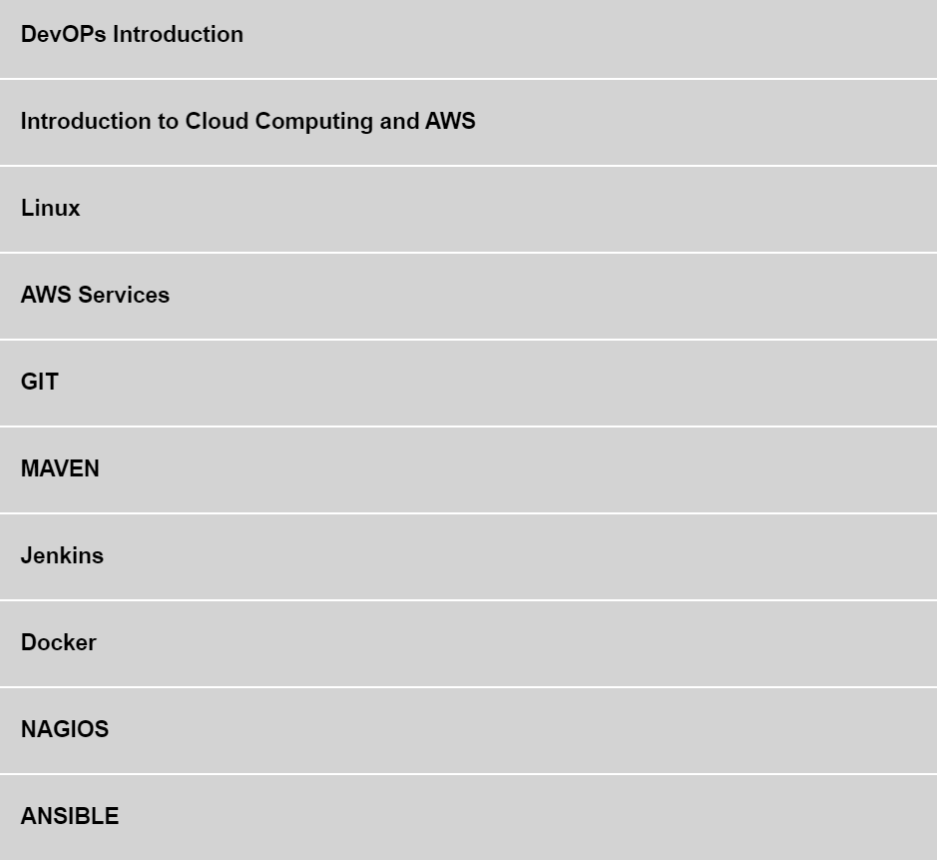

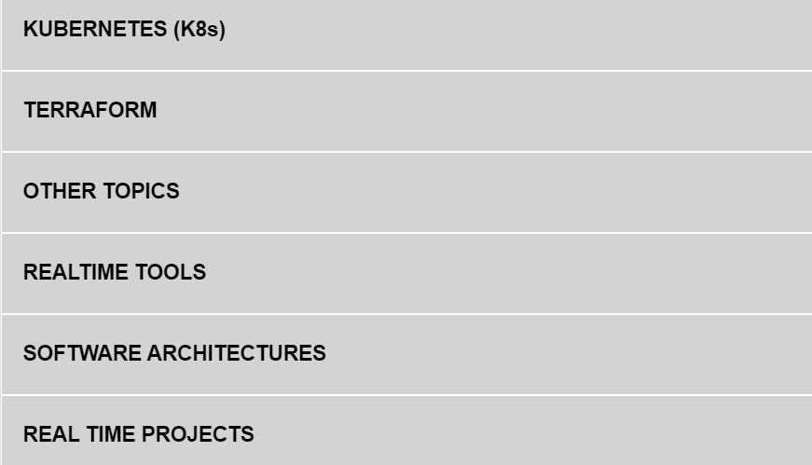

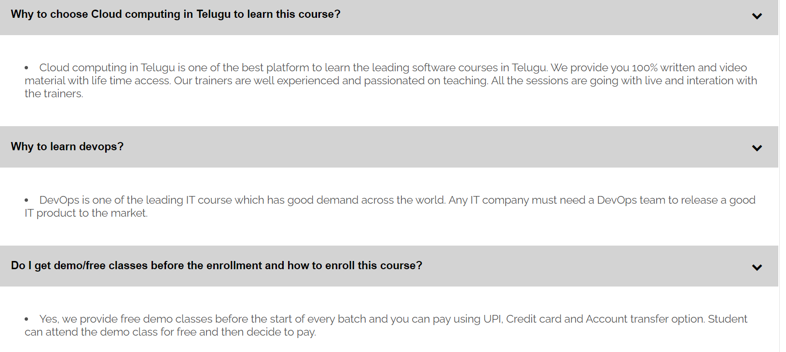

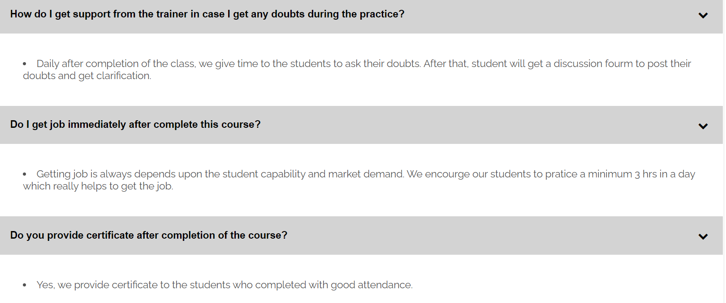

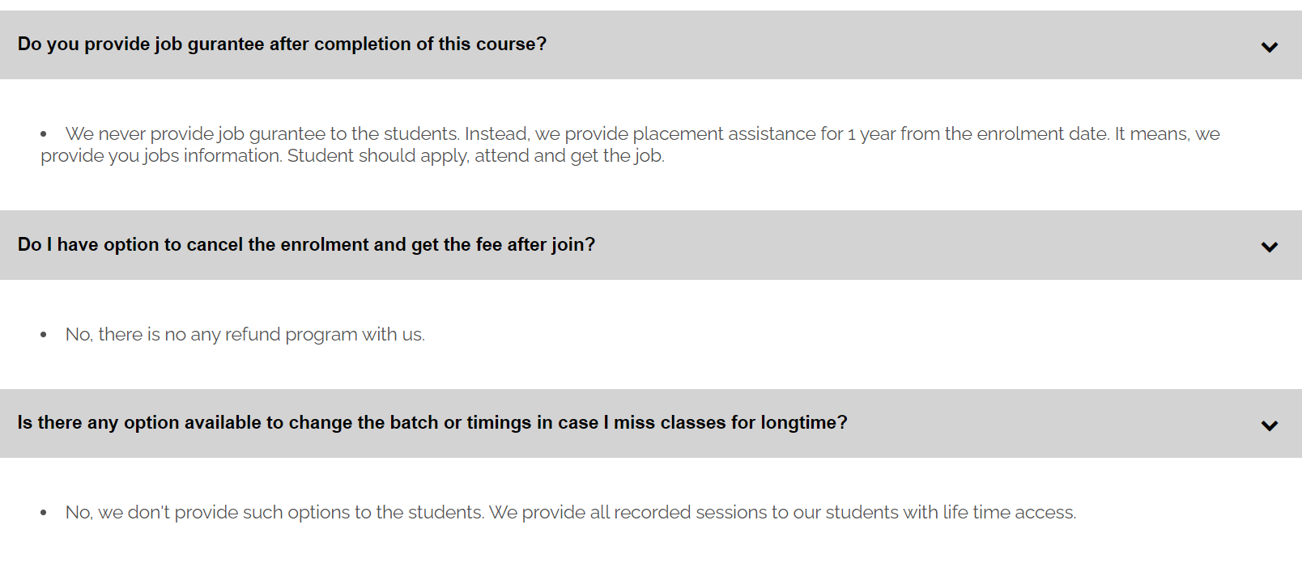

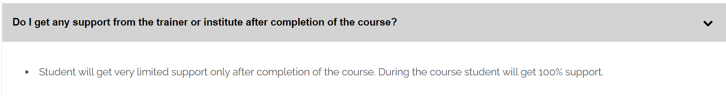

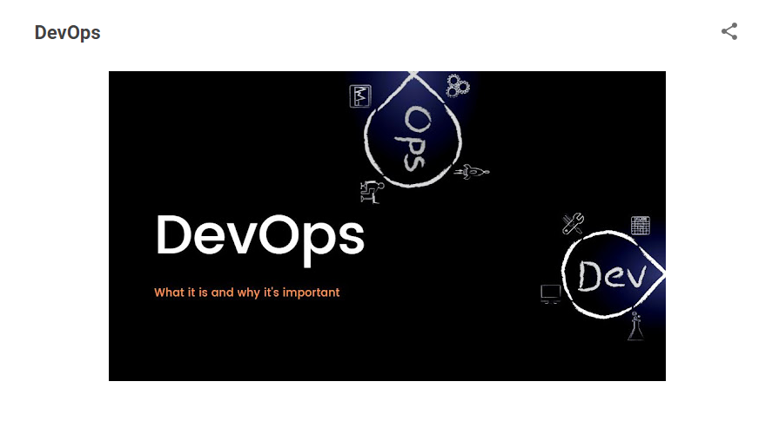

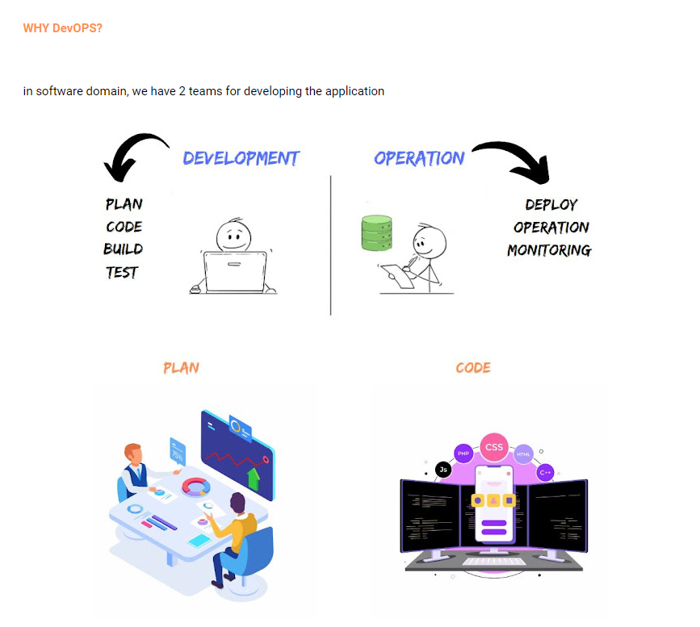

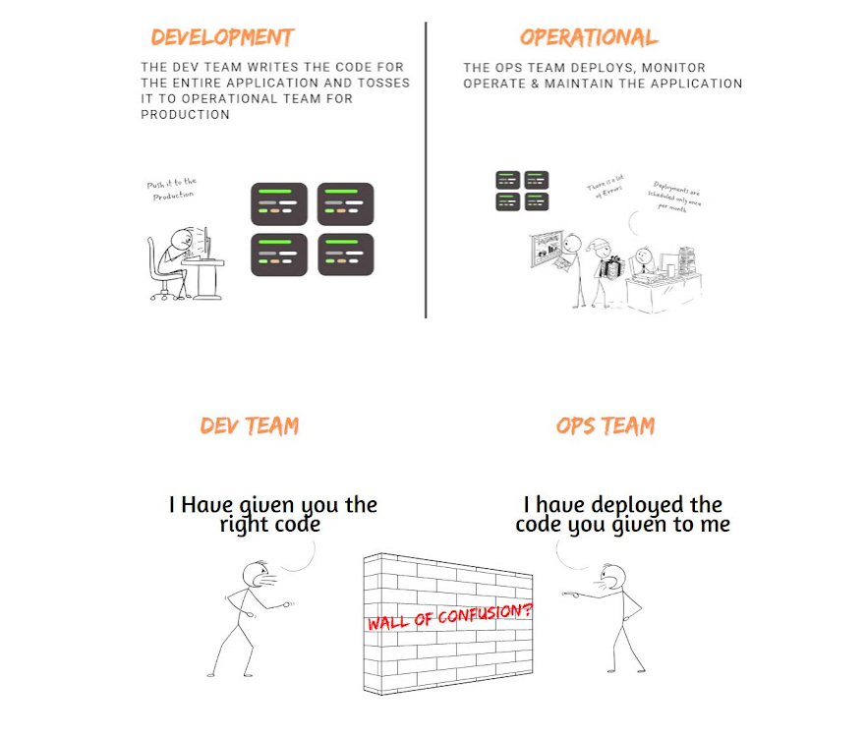

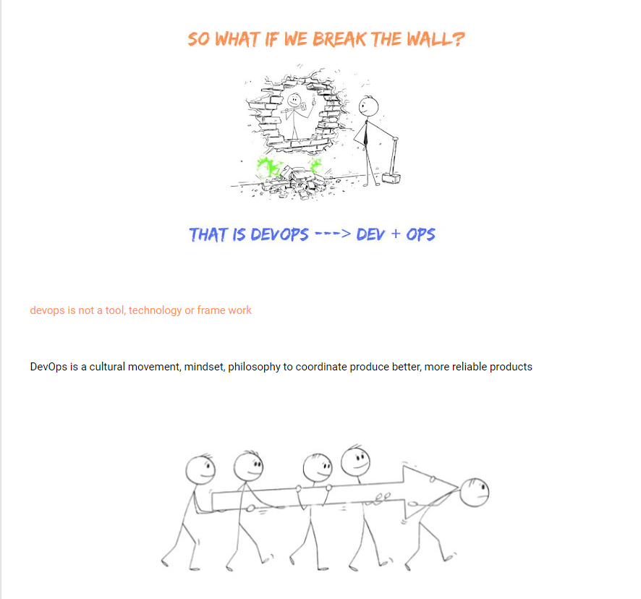

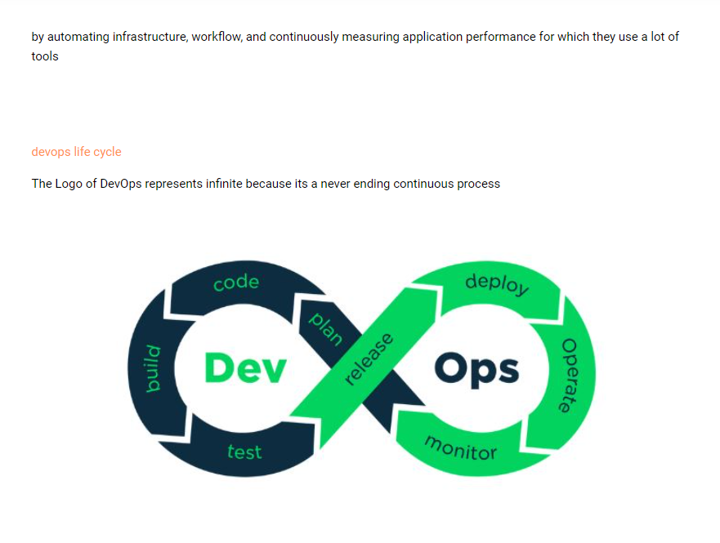

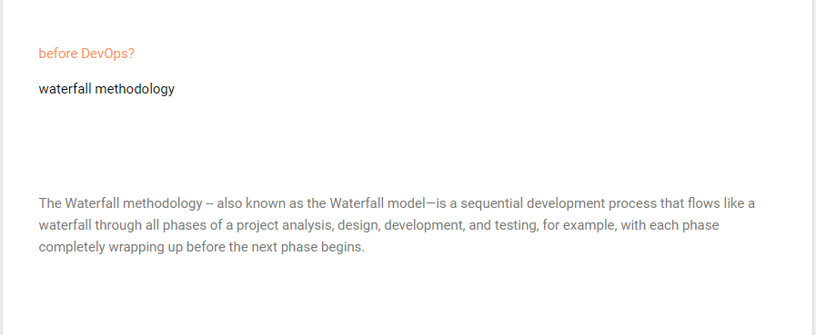

**1. What is SDLC?**

The [**Software Development Life Cycle**](https://www.interviewbit.com/blog/sdlc-vs-stlc/) (SDLC) is a well-defined procedure for producing high-quality, low-cost software in the shortest amount of time possible. The SDLC's purpose is to create exceptional software that exceeds all customer expectations and demands. The SDLC develops and describes a detailed plan that includes stages, or phases, each with its own process and deliverables. It describes the entire development process, including all tasks involved in planning, developing, testing, and distributing a software product.

### 2. the phases in a typical SDLC process

* **Planning:** The first stage of the SDLC is all about determining, what do clients want. Project planning is an important component of the software delivery lifecycle because it is here that the team estimates the cost and outlines the new program's needs.
* **Gathering Requirements:** Defining requirements is part of the planning process to figure out what the application is supposed to perform and what it needs. The development team examines the requirements while keeping the software's design and code in mind.
* **Design:**The following phase entails distilling all of the software project's requirements, analysis, and design information. This phase is the culmination of the previous two, such as customer feedback and requirement collecting. It is a simulation of how a software application will work. Some particulars of this phase are architecture, platform, security and user interface.
* **Development:**This is where the code is really written. Writing code is the first step in putting a design into action. Developers must adhere to the coding requirements set forth by their bosses. Many other jobs are included in the coding process. Many developers need to brush up on their abilities or collaborate with others. It's vital to find and resolve problems and flaws. If any changes or upgrades are needed, the developers can show the work to the business analysts.
* **Testing:** Before making an application available to users, it's vital to test it. The testing team examines the system's overall functionality. This phase aids with reducing the number of faults and issues seen by consumers. As a result, there is a higher level of user satisfaction and a higher rate of utilisation.
* **Deployment:**Once the product has been thoroughly tested and is ready for deployment, it is made available to customers. The deployment's complexity is determined by the project's size. Many businesses prefer to have the deployment step automated.
* **Maintenance:**The developed product is looked after throughout this period. The programme is updated on a regular basis to keep up with the changing user end environment or technology. Users find flaws that were not discovered during testing. These issues must be addressed, which may result in new development cycles.

### 3. The types of SDLC models.

Following are the predominant models that come under SDLC:

* **Waterfall model:**The waterfall model is a prominent software engineering and product development approach that takes a linear, sequential approach to the software development life cycle (SDLC). The waterfall approach emphasises a logical step-by-step process. It was the first model in the software business to be extensively adopted. It is divided into phases, with one phase's output becoming the input for the next. [**Learn More**](https://www.interviewbit.com/blog/waterfall-model-in-software-engineering/).
* **Agile model:** Agile approaches divide jobs into smaller iterations or sections and avoid long-term planning entirely. The scope and requirements of the project are defined at the start of the development phase. The number of iterations, duration, and scope of each iteration are all clearly determined ahead of time. In the Agile process model, each iteration is a small-time "frame" that lasts anywhere from one to four weeks. [**Learn More**](https://www.interviewbit.com/blog/agile-model/).
* **Iterative model:** One of the most straightforward software development life cycle models is the iterative approach. There are several situations when the initial or basic software requirements are well-defined, but the project's complete scope or set of features is unclear. It primarily focuses on preliminary growth and design, then gradually develops momentum as more complex and needs are met until the final software is completely constructed.

## 4.What is DevOps?

DevOps stands for Development and Operations. It is a software engineering practice that focuses on bringing together the development team and the operations team for the purpose of automating the project at every stage. This approach helps in easily automating the project service management in order to aid the objectives at the operational level and improve the understanding of the technological stack used in the production environment.

This way of practice is related to agile methodology and it mainly focuses on team communication, resource management, and teamwork. The main benefits of following this structure are the speed of development and resolving the issues at the production environment level, the stability of applications, and the innovation involved behind it.

**DEVOPS**  
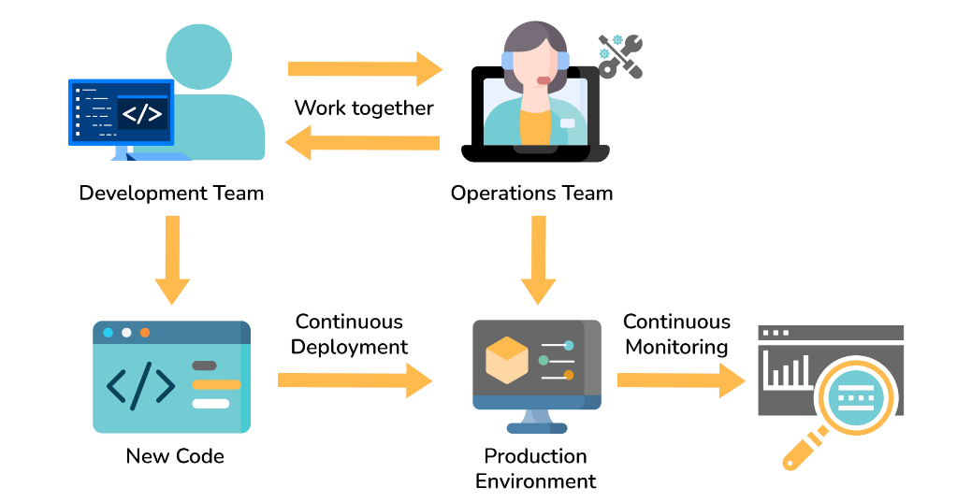

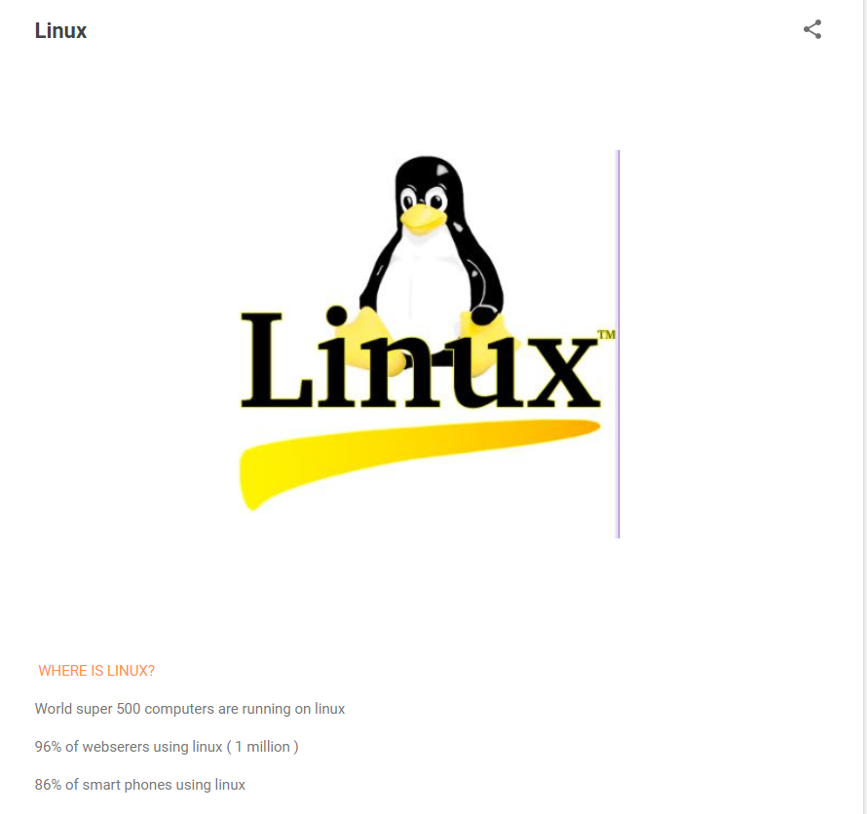

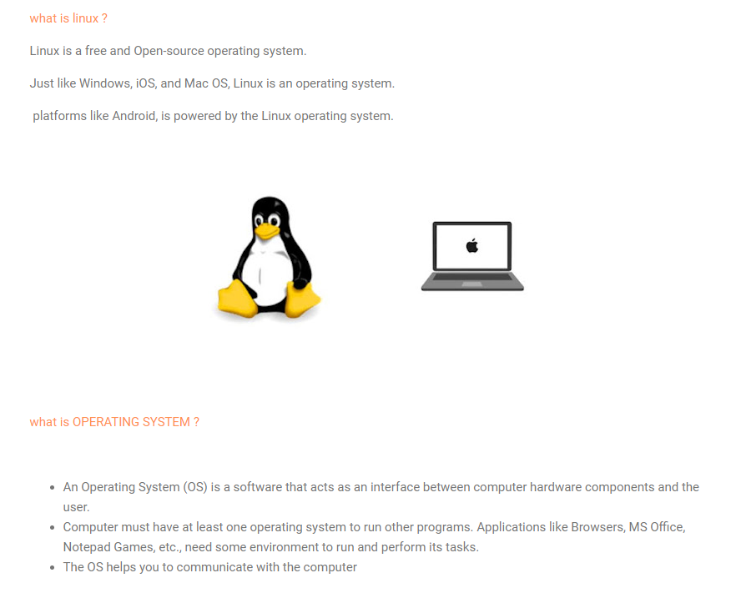

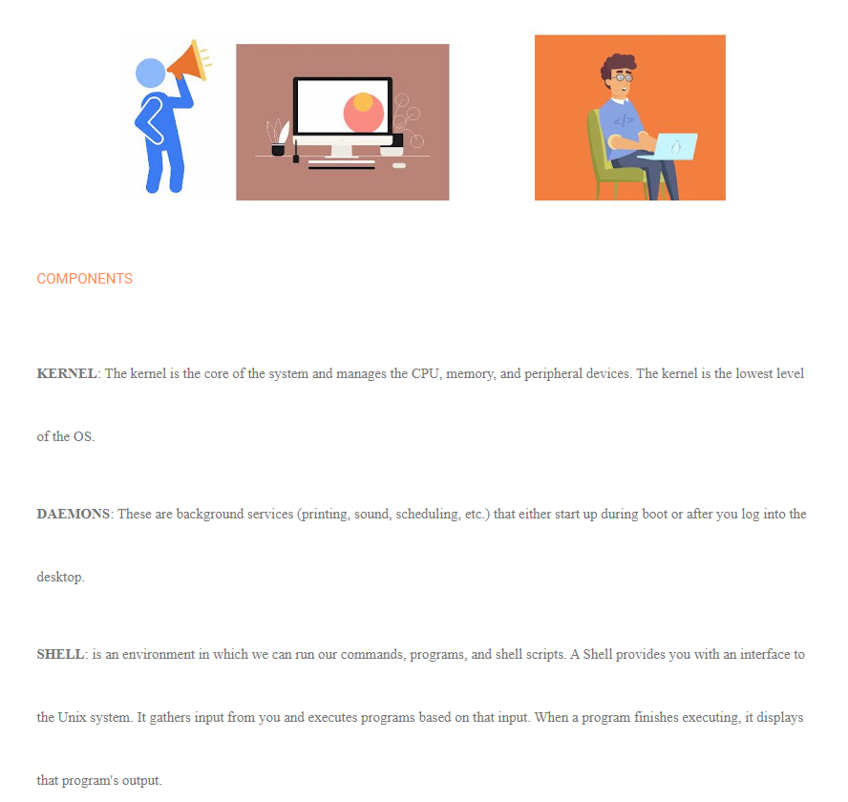

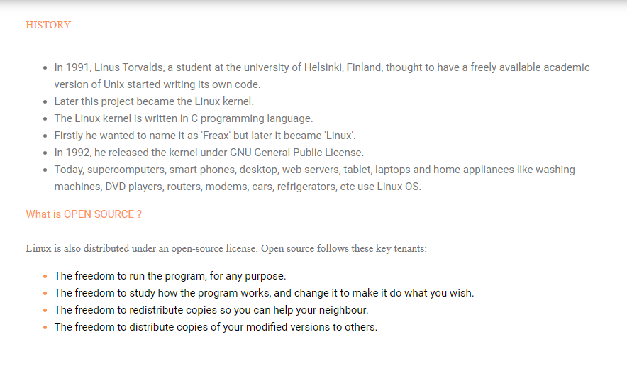

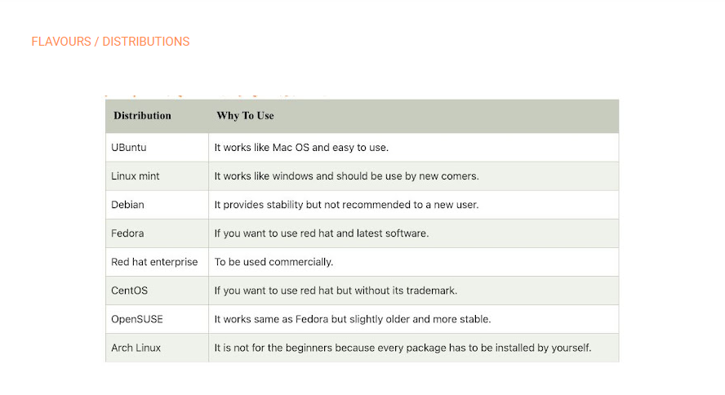

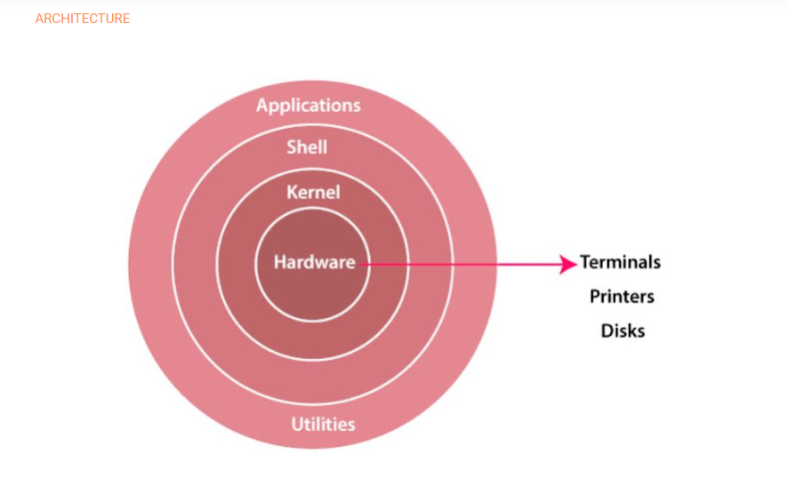

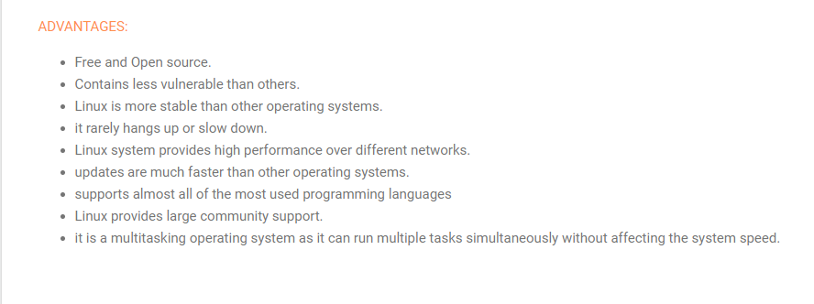

### 5. Who is a DevOps engineer?

A [DevOps engineer](https://www.interviewbit.com/blog/devops-engineer/) is a person who works with both [software developers](https://www.scaler.com/courses/full-stack-developer/) and the IT staff to ensure smooth code releases. They are generally developers who develop an interest in the deployment and operations domain or the system admins who develop a passion for coding to move towards the development side.

In short, a DevOps engineer is someone who has an understanding of SDLC (Software Development Lifecycle) and of automation tools for developing CI/CD pipelines.

### 6. Why DevOps has become famous?

Customer satisfaction is now a motto to the organizations which has also become the goal of any product for its success. In order to achieve this, companies need to do the below things:

* Frequent feature deployments
* Reduce time between bug fixes
* Reduce failure rate of releases
* Quicker recovery time in case of release failures.
* In order to achieve the above points and thereby achieving seamless product delivery, DevOps culture acts as a very useful tool. Due to these advantages, multi-national companies like Amazon and Google have adopted the methodology which has resulted in their increased performance.

**Linux**

**Prerequisites:**

**SSH tools and FTP tools**

**Create an account in AWS**

**Create EC2 instance in AWS**

**Understand the Linux command line**

**Linux file/Directory structure**

**Linux commands**

### 1. What is Linux?

**Ans:**Linux is an operating system, which is based on Linux Kernel.  It is an open-source operating system where it can run on different hardware platforms. It provides a free and low-cost operating system for users. It is a user-friendly environment where they can easily modify and create variations in the source code.

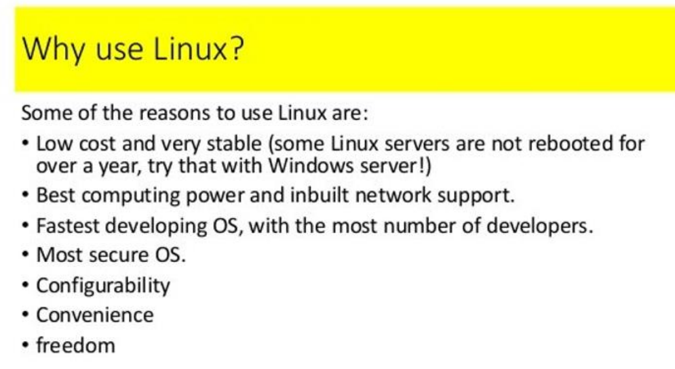

**What is the difference between Linux and Windows?**

**Ans:**

|  |  |
| --- | --- |
| **Linux** | **Windows** |
| Linux is available for FREE | It is paid software |
| It is an Open-Source operating system | It is not an open-source OS |
| Linux customization is possible | No customizations are available |
| It provides high-level security | Can't defend virus and malware attacks unless until it is paid |
| Primary partitioning and logical partitioning available to boot | Booting available while primary partitioning only |
| BackSlash separates directories | The forward slash separates directories |
| File names are case particular | Irrespective of the case while naming files |

**2.What is the difference between Linux and Unix?**

**Ans:**Here is the difference between Linux and Unix - mentioned below

|  |  |
| --- | --- |
| **Linux** | **Unix** |
| Both paid and free distributions are available. | Different paid structures for different levels of Unix. |
| Linux primarily uses GUI with an optional command-line interface | Unix uses the command-line interface |
| Linux OS is portable and can be executed on different hard drives | Unix OS is not portable. |
| Linux is developed by a worldwide Linux community. | Unix is developed by AT&T developers. |
| Linux is free. And it is download through the internet under GNU licenses. | Most Unix Like Operating Systems is not free. |
| Linux is used at home-based PC's, phones, etc. | Unix is used in server systems. |

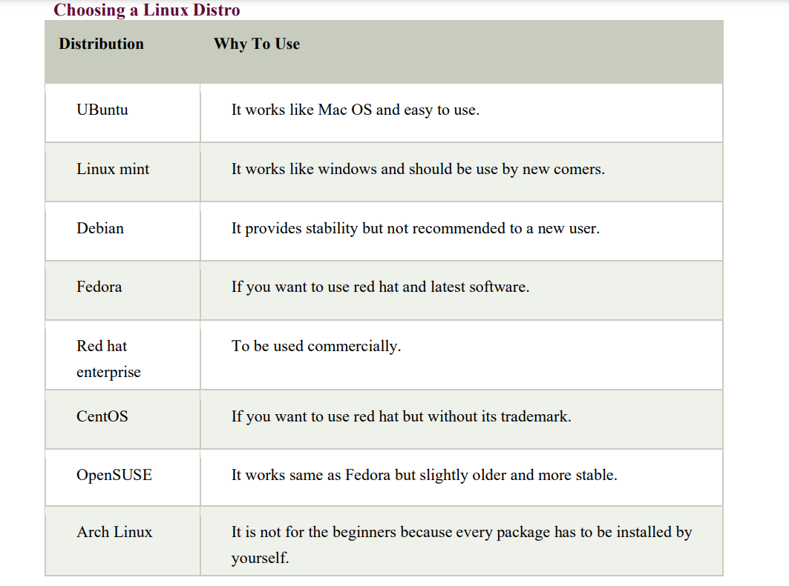

**3.What are the basic components of Linux?**

**Ans:**Basic components of Linux

1. **Kernel:** It is the core component of Linux, it acts as an interface between software and hardware.
2. **Shell:** It acts as an interface between the user and the Kernel.
3. **GUI:**  It stands for Graphic User Interface, which is another way for the user to interact with the system. But it is unlike images, buttons, text boxes for interaction.
4. **System Utilities:** These are the software functions that allow users to manage the computer.
5. **Application Programs:** A set of functions designed to perform a set of tasks.

**What are the features of the Linux operating system?**

**Ans:**Following are the features of the Linux Operating System

* **Portable:** Software can work on different types of hardware in the same way. It can carry easily in pen drives and memory cards.
* **Open Source:** Source code available for free, and its community-based development project.
* **Multi-User:** Multiple users can use ram, applications and run programs at the same time.
* **Multiprogramming:** Multiple programs or applications can run at the same time.
* **Shell:** It has a special interpreter program where you can execute programs and commands of the system.
* **Security:** It provides authentication, authorization, and encryption to provide security to the data.

**4. What is CLI?**

**Ans:**CLI means Command language Interpreter. It interacts with the computer program, where the user issues command in the form of text lines. It Interacts with the computer terminals also, the interface accepts the text lines and converts them as a command to the operating system.

**5. What is the advantage of Open Source?**

**Ans:**Linux was one of the first open-source technologies, many programmers added software that completely open to the users, which means you can download the file and change the code as you like. It has a wide range of options for users and increased security.

**6. What is the disadvantage of Open Source?**

**Ans:**Disadvantages of Open Source Operating System mentioned below

1. Difficulty of use
2. Compatibility Issues
3. Liabilities and warranties
4. Hidden costs

7.**What is mkdir in Linux?**

**Ans:**mkdir, command allows users to create directories in Linux. Users can create multiple directories at once and can set the permissions to the directories.

**Syntax:**

mkdir [options...] [directories ...]

|  |  |
| --- | --- |
| **Option** | **Description** |
| Directory | name of the directory to be created |
| -m=mode, --mode=mode | to set a file mode (permissions, etc.) for the created directories |
| -p, --parents | create parent directories |
| --v, --verbose | Verbose output. Print a message for the created directory. |
| --Z= context, --context=context | If you are using SELinux, this option sets the security context of each created directory to context. |
| --help | shows help message and exit |
| --version | It shows version information and exit |

### What is the 'ls' command and what it does?

**Ans:**It is one of the basic commands in Linux. It is used to list all the files and directories in the file

**Syntax:**

ls [OPTIONS] [FILES]

**How to remove a file or directory from the system in Linux?**

**Ans:**rm command: The rm command is used to remove the directory or file specified on the command line. You need to be careful while removing any file or directory.

**Syntax:**

rm filename---

|  |  |
| --- | --- |
| **Command** | **Description** |
| rm filename | Removes single file. |
| rm filename1, filename2, filename 3 | Removes multiple files. |
| rm * .pdf | Removes all pdf files in the current directory. |
| rm -i filename(s) | -i mean to confirm before deleting the file |
| rm -f filename(s) | Removes files without prompting |
| rm -fv *.txt | Remove all .txt files in the current directory without prompting |

### What is Amazon EC2?

Amazon EC2 is known as Amazon Elastic Cloud Computing Platform. It provides a robust computing platform to handle any workload with the latest processors, storage, Operating Systems, and networking capabilities. It simplifies the computing process for developers. And this service reduces time by allowing quick scaling as per the requirements.

**Mention what the key components of AWS are?**

The key components of AWS are

* **Route 53:**A DNS web service
* **Simple E-mail Service:**It allows sending e-mail using RESTFUL [API](https://career.guru99.com/top-20-questions-on-api-testing/) call or via regular SMTP
* **Identity and Access Management:**It provides enhanced security and identity management for your AWS account
* **Simple Storage Device or (S3):**It is a storage device and the most widely used AWS service
* **Elastic Compute Cloud (EC2):**It provides on-demand computing resources for hosting applications. It is handy in case of unpredictable workloads
* **Elastic Block Store (EBS):**It offers persistent storage volumes that attach to EC2 to allow you to persist data past the lifespan of a single Amazon EC2 instance
* **CloudWatch:**To monitor AWS resources, It allows administrators to view and collect keys. Also, one can set a notification alarm in case of trouble.

**While connecting to your instance what are the possible connection issues one might face?**

The possible connection errors one might encounter while connecting instances are

* Connection timed out
* User key not recognized by the server
* Host key not found, permission denied
* An unprotected private key file
* Server refused our key or No supported authentication method available
* Error using MindTerm on Safari Browser
* Error using Mac OS X RDP Client

### What are key-pairs in AWS?

Key-pairs are secure login information for your virtual machines. To connect to the instances, you can use key-pairs which contain a public-key and private-key.

**What are the different types of instances?**

Following are the types of instances:

* General purpose
* Computer Optimized
* Memory Optimized
* Storage Optimized
* Accelerated Computing

**List different types of cloud services**

Various types of cloud services are:

* Software as a Service (SaaS),
* Data as a Service (DaaS)
* Platform as a Service (PaaS)
* Infrastructure as a Service (IaaS).

**Explain File Permissions types in Linux?**

**Ans:**Linux file permissions - Each file or directory has 3 permissions

They are

1. **Read:**It refers to only they can read the file.
2. **Write:**It refers that they can write the file or modify the file of a directory.
3. **Execute:** It affects the user’s capability to execute the file or to view the file of a directory.

### Describe the root account?

**Ans:**The root is the user name, which default has access to all files and commands. The root user can do many things, but an ordinary user cannot do like installing software, changing file permissions, etc.

### What are the symbolic links?

**Ans:**It will be redirected to another file using its path. Target files do not contain any data. Symbolic links redirect to another entry somewhere in the file system. If the target file is deleted, the link to that file is removed, but not the file.

### What are the hard links?

**Ans:**A hard link is another name for an existing file on Linux. We can create so many numbers of hard links, for any file. They can create links for other hard links.

**What are the different modes when using the vi editor?**

**Ans:**There are three kinds of modes in vi editors. They are

* Command Mode/ Regular Mode
* Insertion Mode/Edit Mode.
* Ex Mode/ Replacement Mode.

### What are inode and process id?

**Ans:**The inode is a unique name given to each file and the process id is a unique name given to each process.

**What are the Process states in Linux?**

**Ans:**Five process states in Linux. They are

1. **New/ Ready:** A new process is created and ready to run.
2. **Running:** The process is being executed.
3. **Blocked/ Wait:** The process is waiting for input from the user.
4. **Terminated/ Completed:** The process completed the execution or terminated by the operating system.
5. **Zombie:** The process is deleted, but still the information regarding the process exists in the process table.

### What is umask?

**Ans:**unmask stands for user file creation mode. When the user creates any file, it has default file permissions. So unmask will specify few restrictions to the newly created file (it controls the file permissions).

### How to check which ports are listening in my Linux Server?

**Ans:**We have two commands to check which ports are in listening in Linux Server. Following are the two commands

# netstat --listen

# netstat -l

**What are the default ports used for SMTP, DNS, FTP, DHCP, SSH, and squid?**

**Ans:**Details mentioned below

|  |  |
| --- | --- |
| **Service** | **Port** |
| SMTP | 25 |
| DNS | 53 |
| FTP | 20(Data Transfer) 21(Connections Established) |
| DHCP | 68(dhcp client), 67(DHCP server) |
| SSH | 22 |
| Squid | 3128 |

### What is the tail command in Linux?

**Ans:**The Tail command print the last N number of lines of the given data, it prints 10 lines by default.

**Syntax:**

tail [OPTION]... [FILE]

### What is ps command in Linux?

**Ans:**The ps command displays the current process status of the system. And it displays the processes id’s with some other related data also.

**Syntax:**

Ps [options]

### What is the env command in Linux?

**Ans:**env is a shell command is used to print a list of current environmental variables and it can run another process in another environment without any modification of the current environment.

env [OPTION]... [-] [NAME=VALUE]... [COMMAND [ARG]...]

### What is the top Command in Linux?

**Ans:**The top command is used to show the system process and it displays and updates the sorted process information.

### What is netstat command in Linux?

**Ans:**netstat command gives various information about the network and routing tables, interface statics and more about the system.

**Explain about chmod command?**

**Ans:**This command is used to change the permission of files and directories. It’s an important command so, I'll explain it briefly. Therefore, on the whole, there are three ty0pe of permission, read, write and execute and are represented by numbers as shown below.

1. **4 -** read permission
2. **2 -** write permission
3. **1-** execute permission

### What is the cp command in Linux?

**Ans: cp command:** cp command is used to copy files and directories. It is also used to backup files or directories.

**Syntax:**

$ cp filename

### Explain rmdir command in Linux?

**Ans:**The rmdir is used to remove each directory specified on the command line.

**Enlist some Linux to file content commands?**

**Ans:**File content commands

1. **head:** Display top lines of the file.
2. **tail:** Display the last lines of the file.
3. **cat:** Concatenate more than 2 files.
4. **more**: Displays the content in pager form to view in the terminal.

### What is Zombie Process?

**Ans:**It is a process whose execution is completed but even the information exists in the process table. It occurs for the child process because the parent process needs to read the child process status. Once it is completed using the wait system call, then the zombie process is removed from the process table. This is known as Zombie Process.

### What is the grep command in Linux?

**Ans:**grep searches file patterns. If you are looking for a specific pattern in the output of another command, grep highlights the relevant lines. Use this grep command for searching log files, specific processes, and more.

### What is the df command in Linux?

**Ans:**Users can use the df command to troubleshoot disk space issues. Here df stands for display free disk space.

**df Command Example:**

df -h

### What is a du command in Linux?

**Ans:**du command in Linux is used to retrieve more detailed information about which files use the disk space in a directory.

**du Command Example:**

$ du -sh /var/log/*

1.8M /var/log/anaconda

384K /var/log/audit

4.0K /var/log/boot.log

0 /var/log/chrony

4.0K /var/log/cron

4.0K /var/log/maillog

64K /var/log/messages

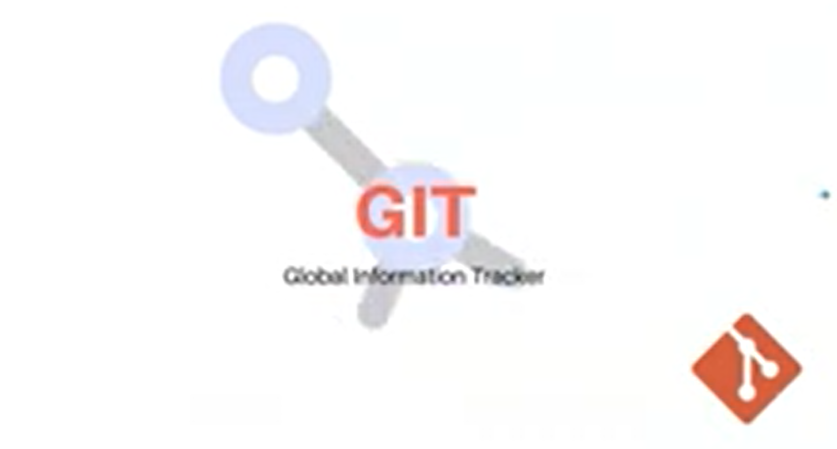

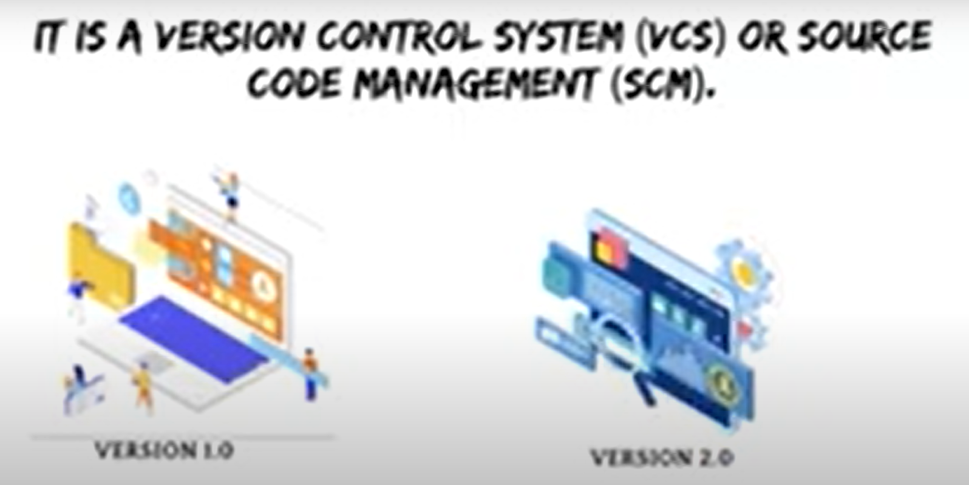

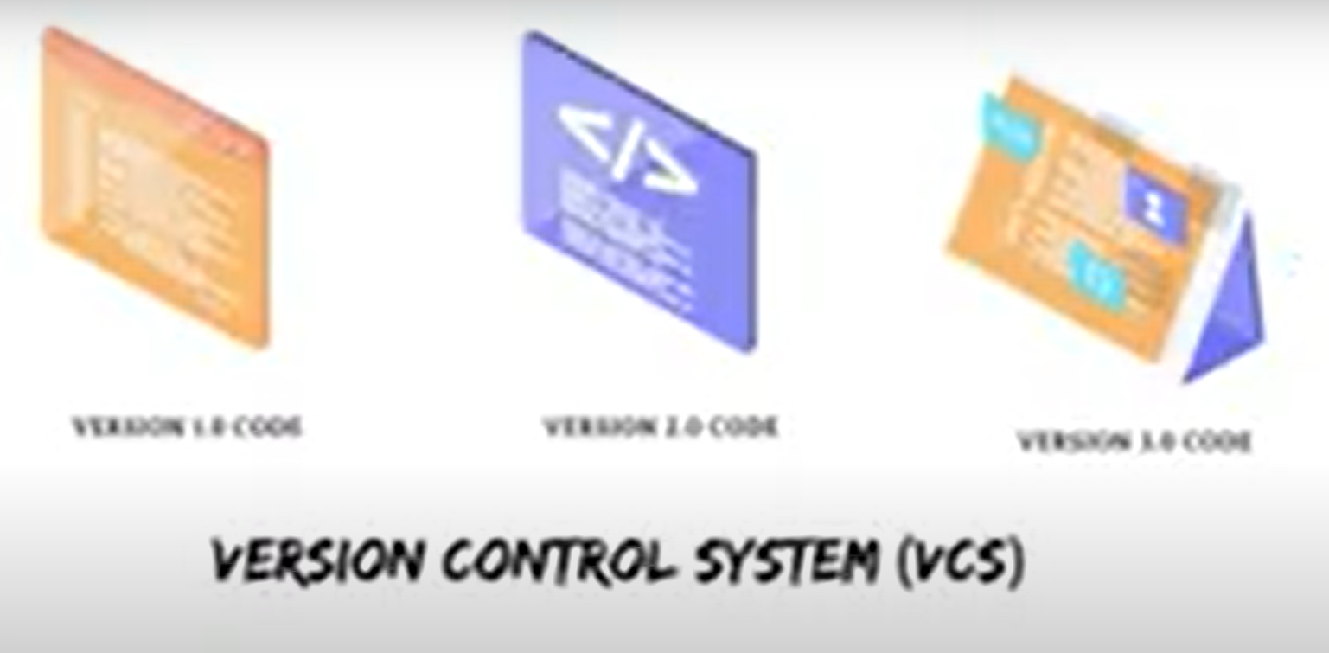

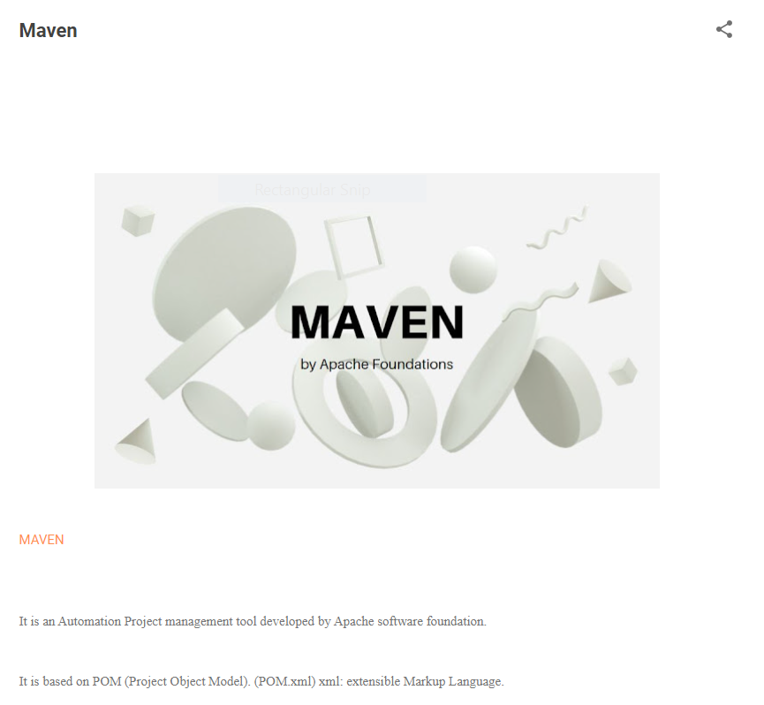

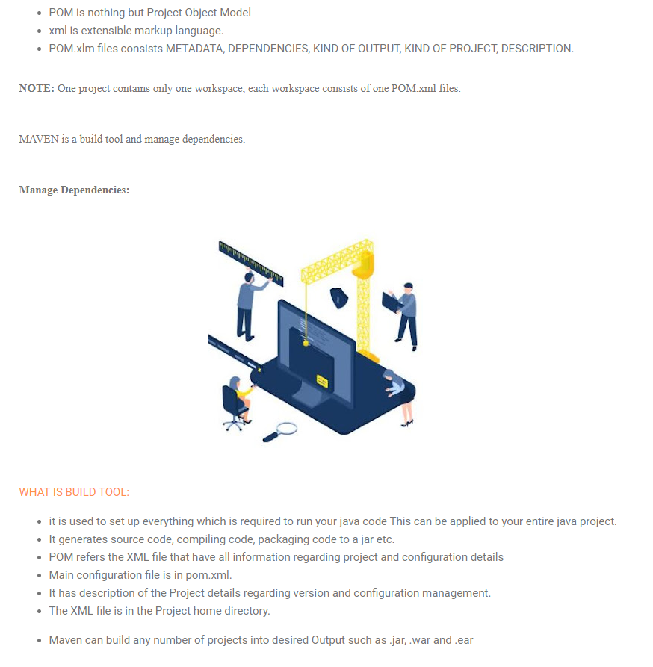

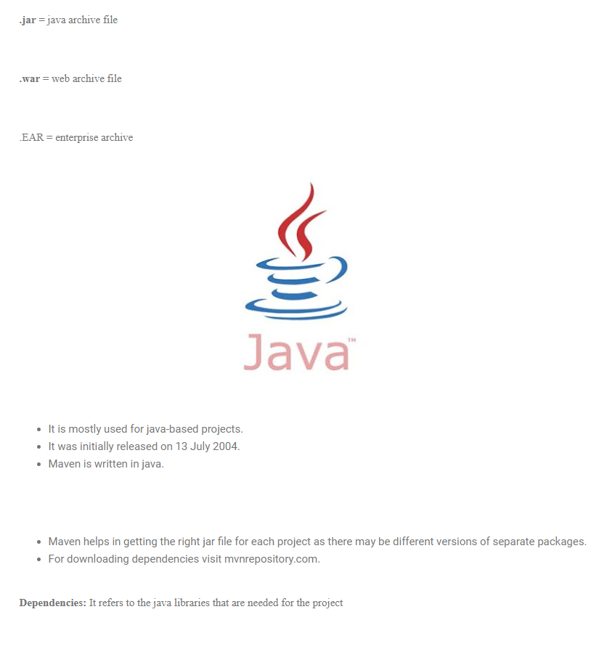

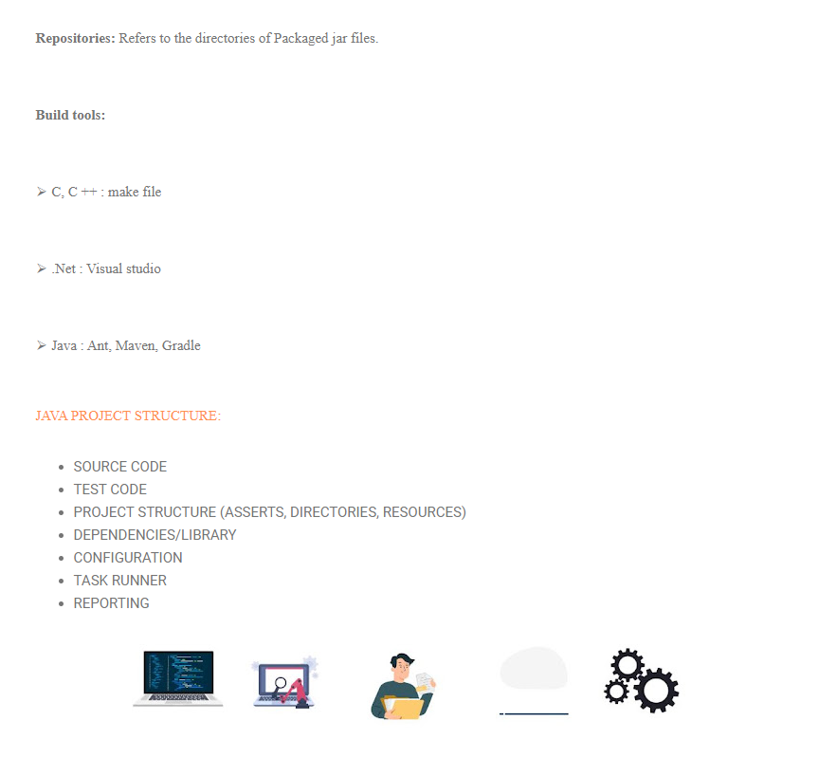

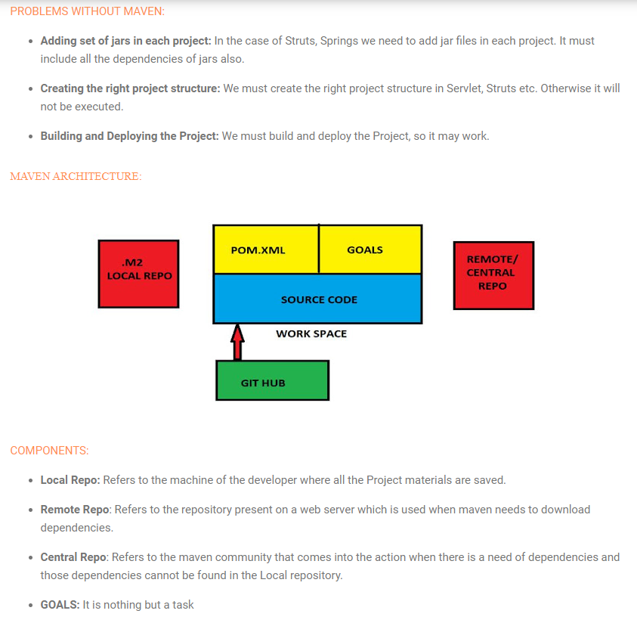

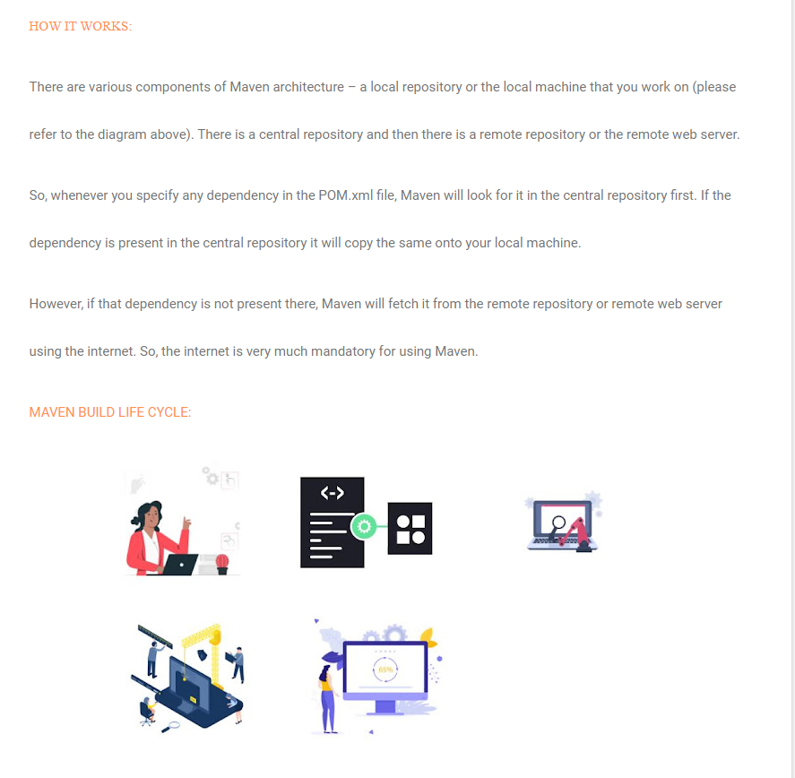

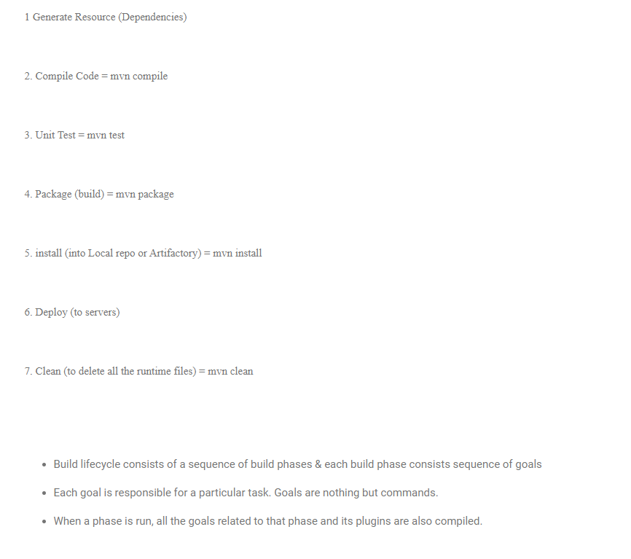

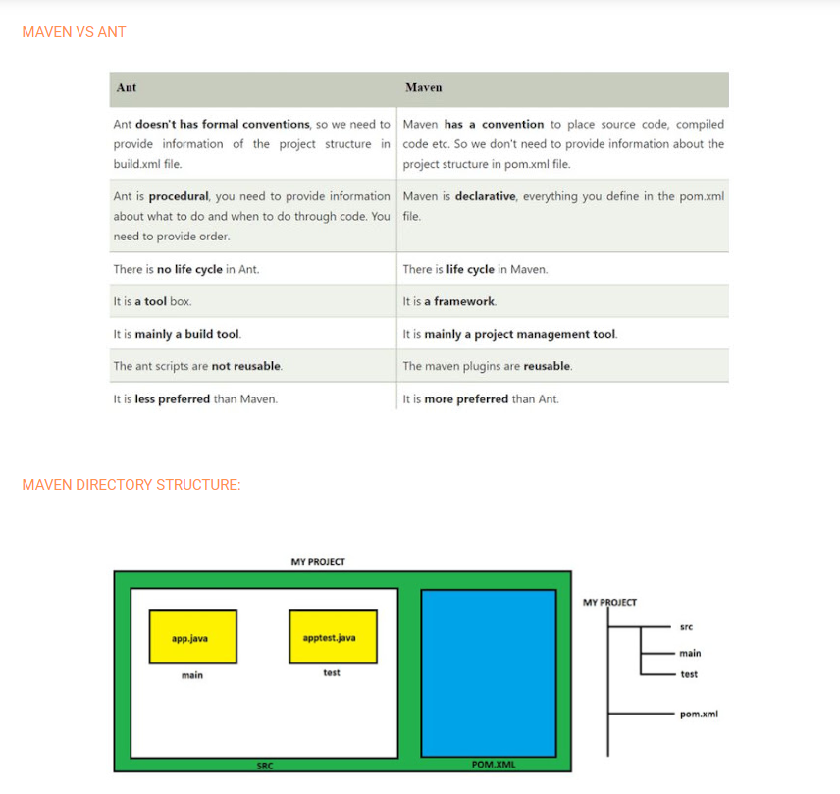

Jenkins

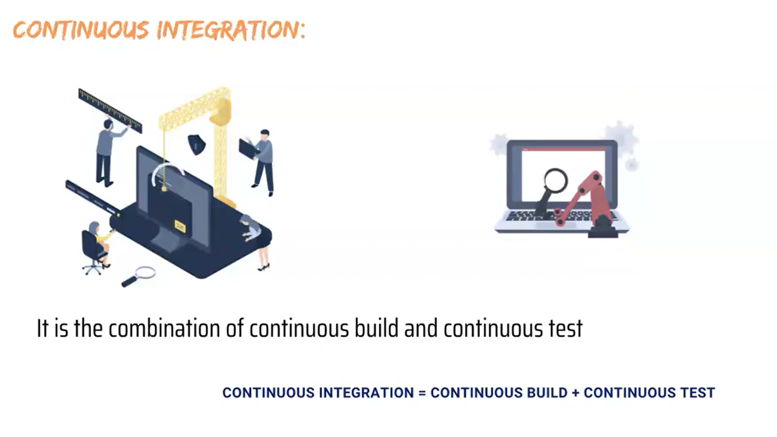

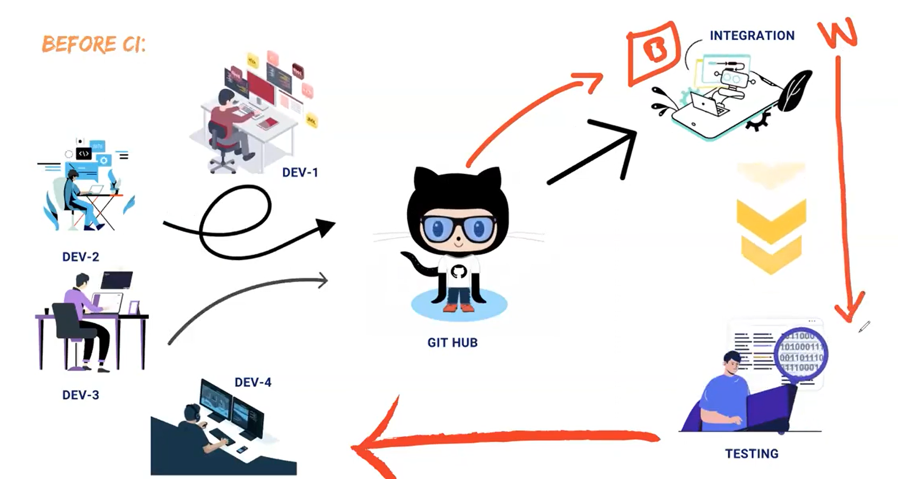

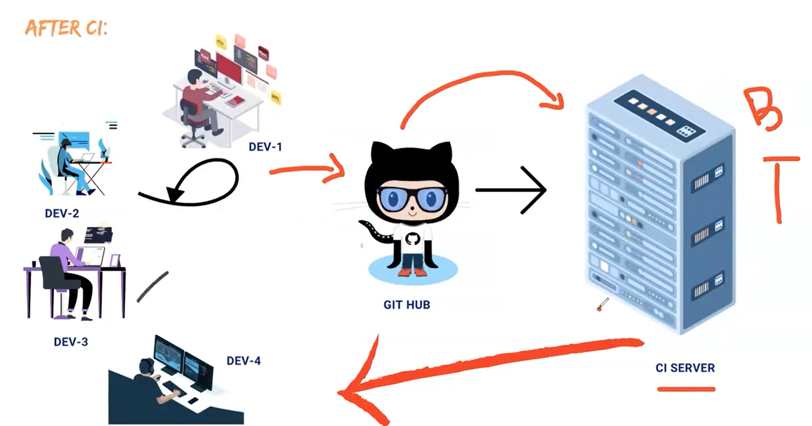

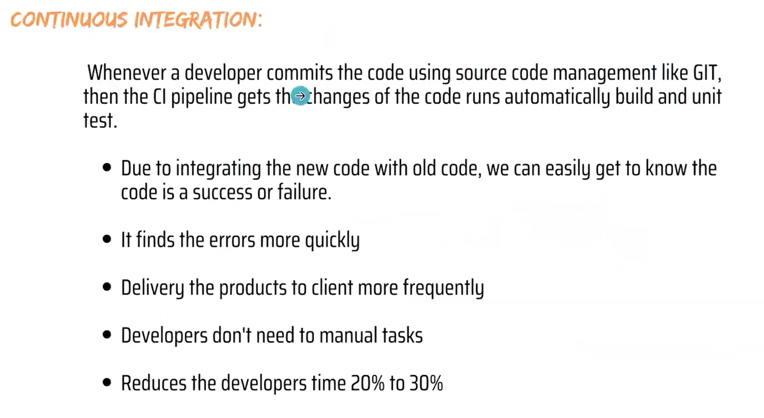

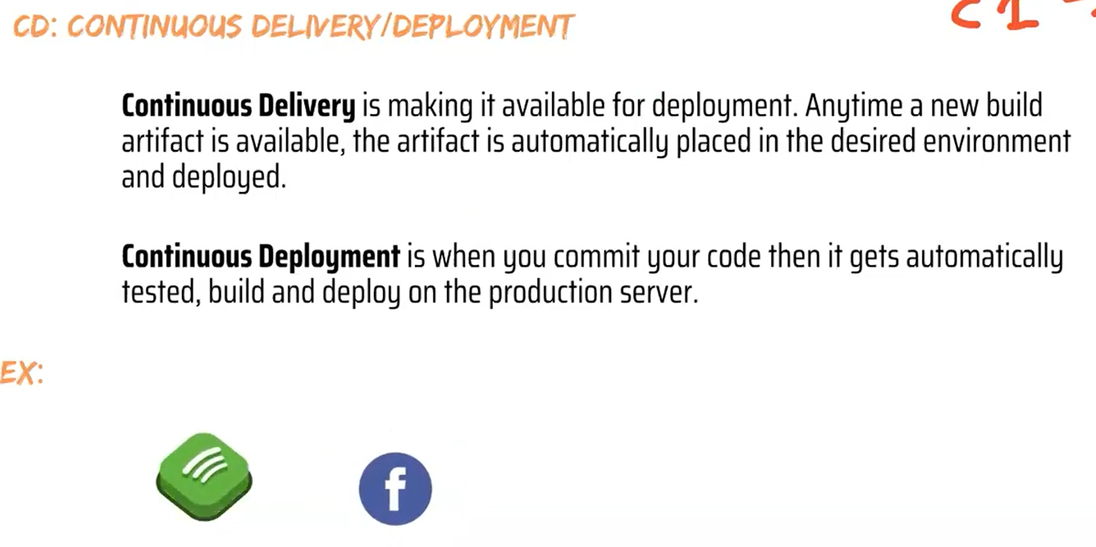

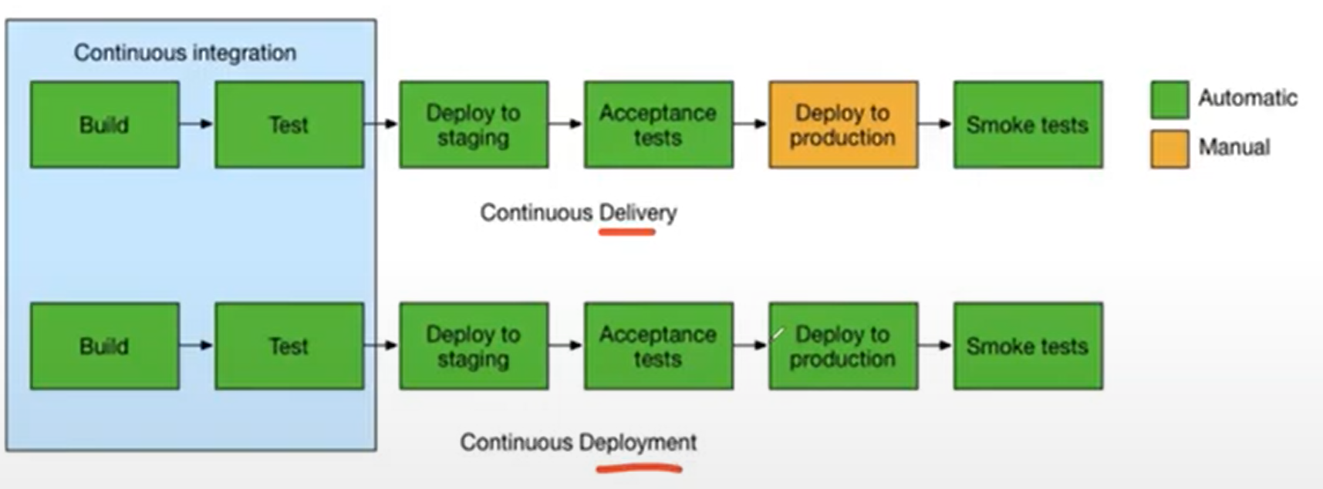

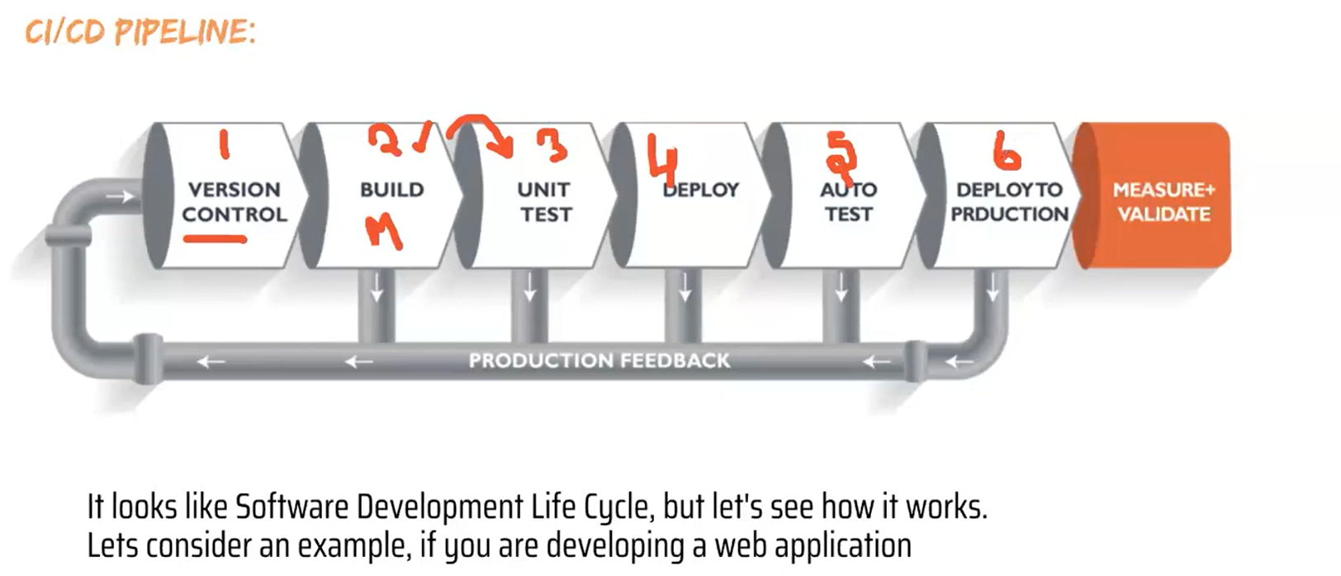

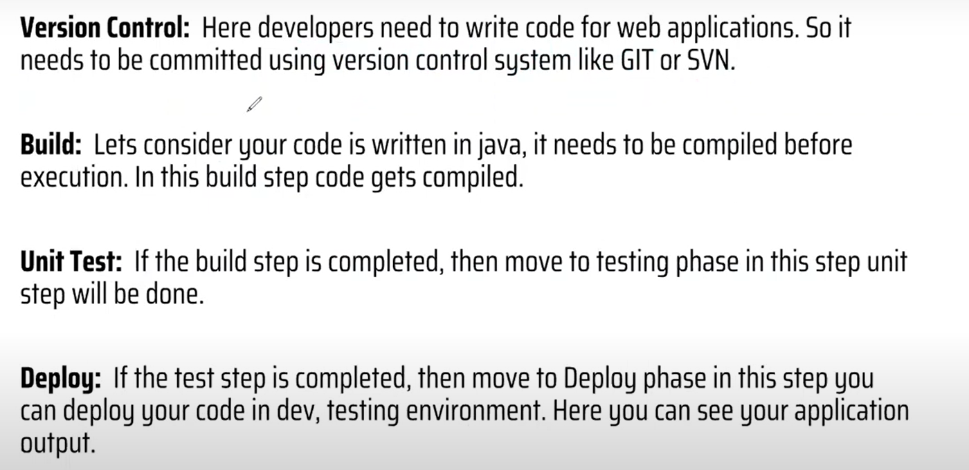

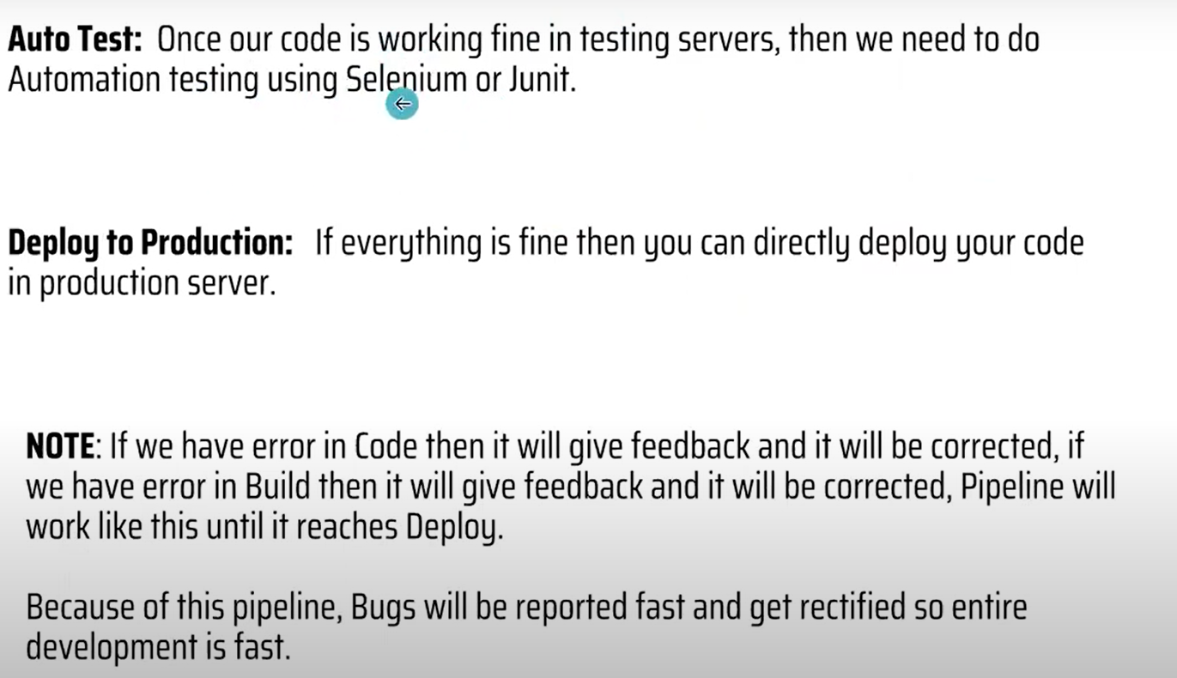

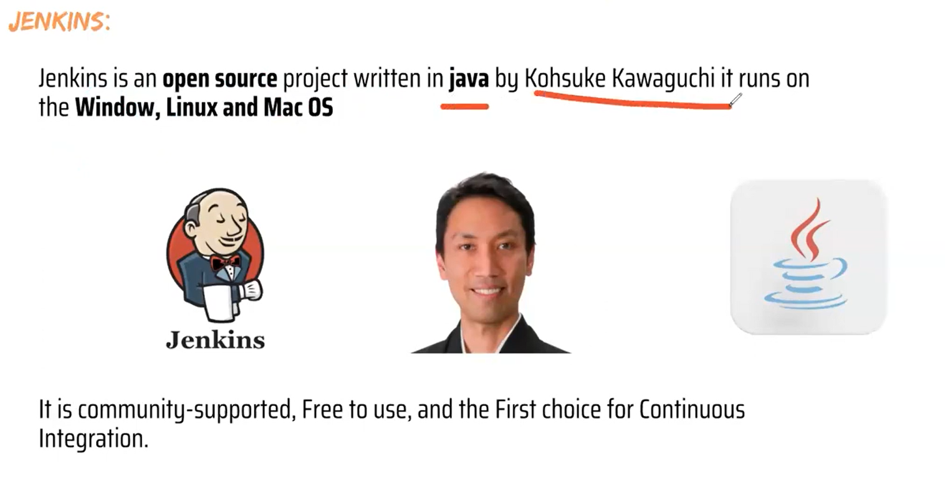

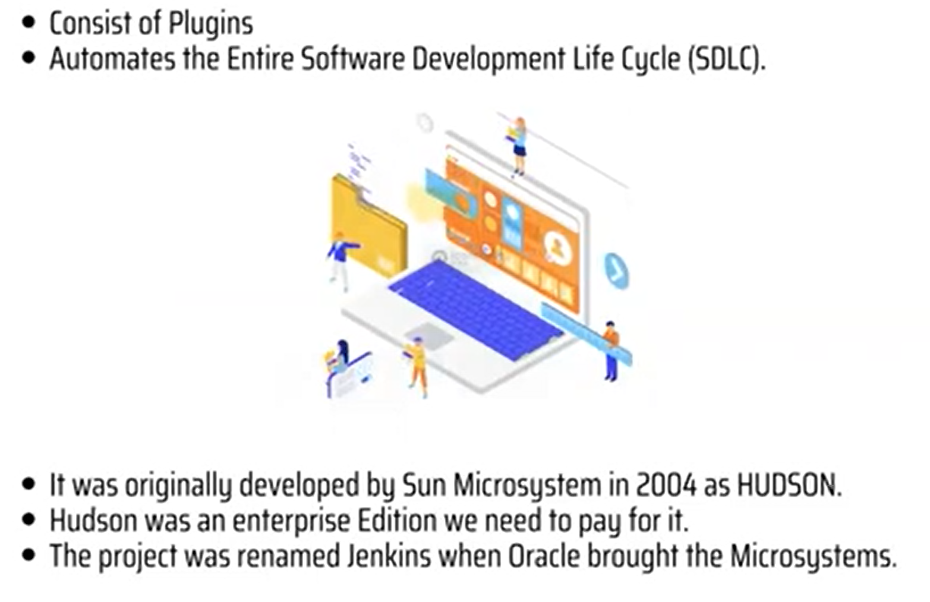

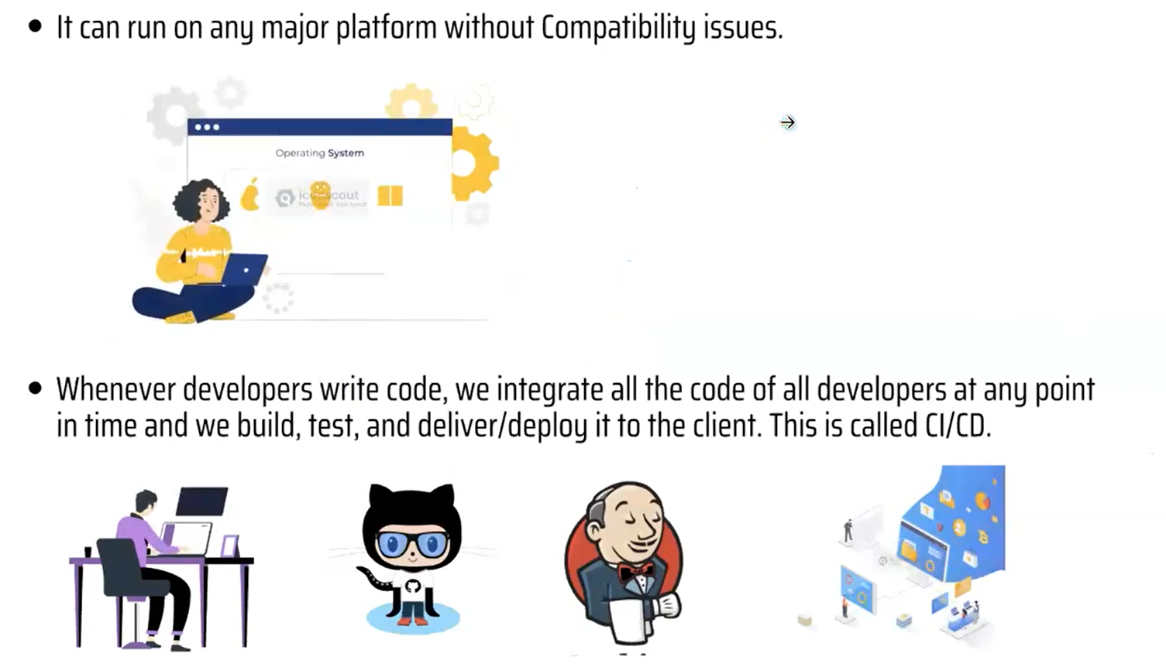

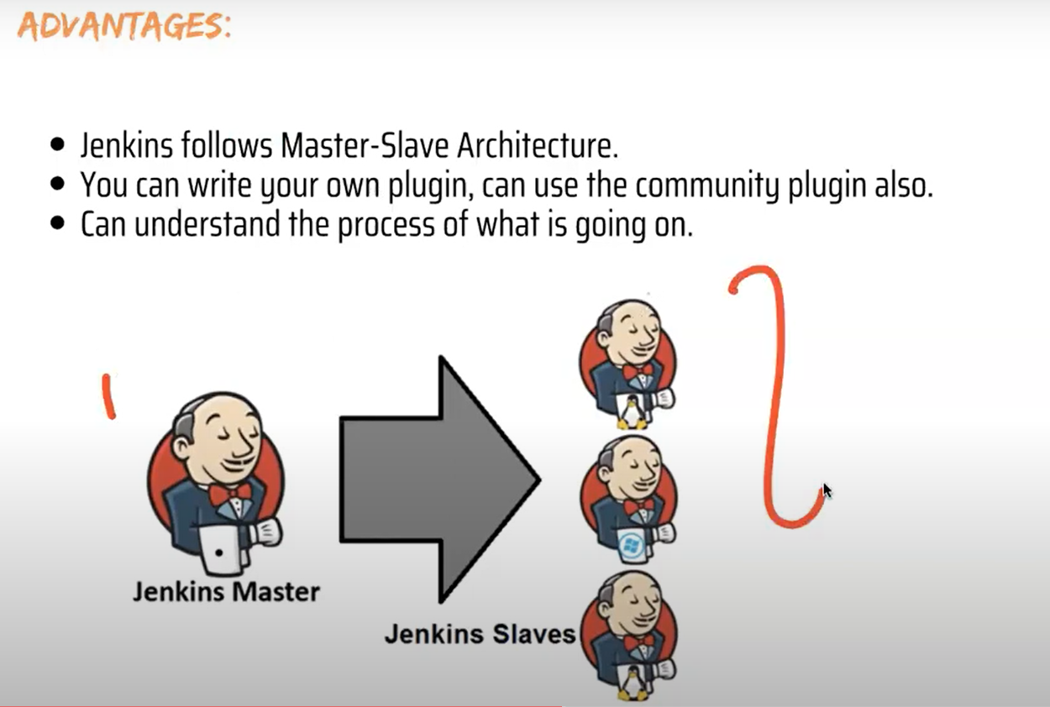

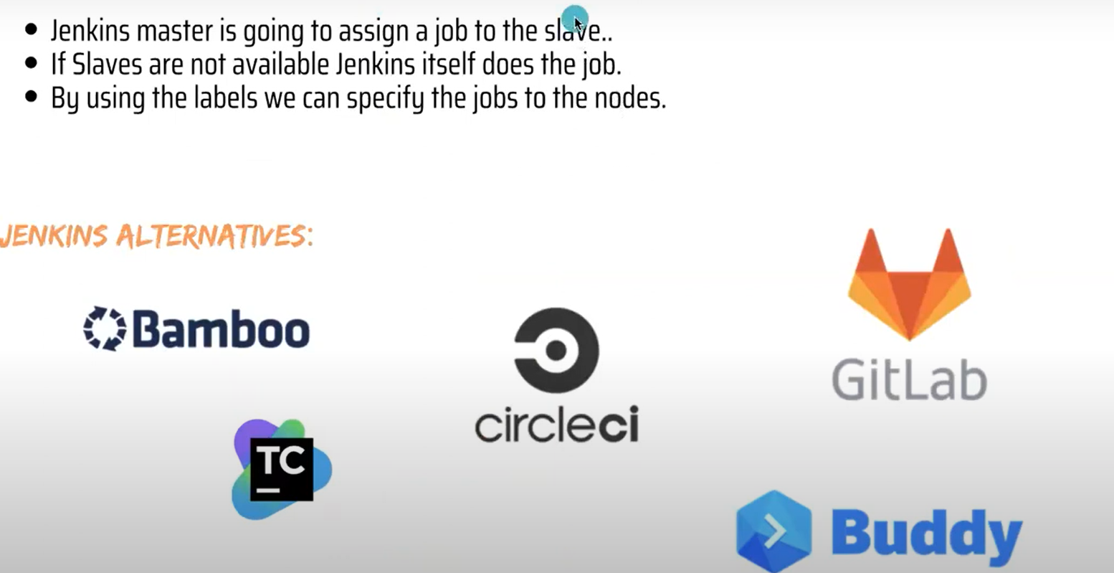

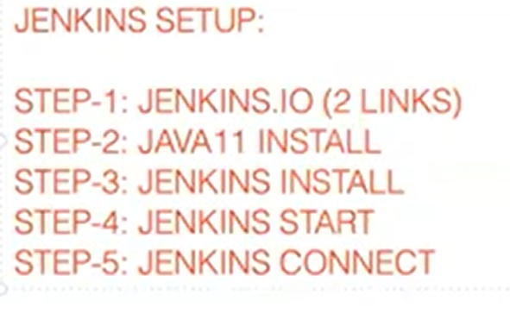

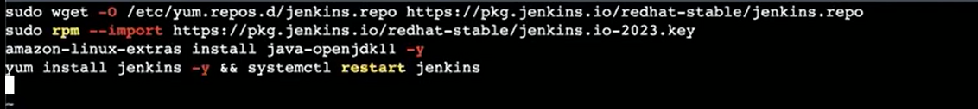

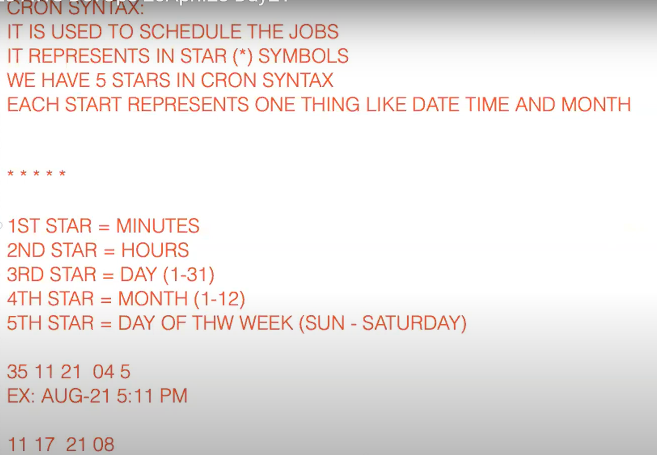

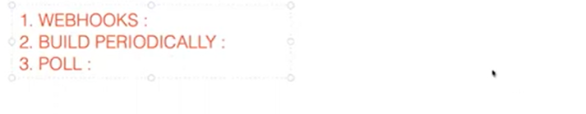

Jenkins Pipeline supports two syntaxes for defining pipelines: Scripted Pipeline and Declarative Pipeline.

Scripted Pipeline is the traditional way of defining pipelines in Jenkins. It allows you to write pipeline scripts using the Groovy programming language. Scripted pipelines provide a lot of flexibility and power, but can be complex to write and maintain.

Here is an example of a Scripted Pipeline that builds and deploys a Java web application:

javascript

Copy code

node {

stage('Build') {

sh 'mvn clean install'

}

stage('Deploy') {

sh 'docker build -t myapp .'

sh 'docker run -p 8080:8080 myapp'

}

}

Declarative Pipeline is a newer syntax for defining pipelines in Jenkins. It provides a simpler and more structured way of defining pipelines using a set of predefined directives. Declarative pipelines are easier to read and maintain, and are designed to be more human-readable.

Here is an example of a Declarative Pipeline that builds and deploys a Java web application:

typescript

Copy code

pipeline {

agent any

stages {

stage('Build') {

steps {

sh 'mvn clean install'

}

}

stage('Deploy') {

steps {

sh 'docker build -t myapp .'

sh 'docker run -p 8080:8080 myapp'

}

}

}

}

In this example, the pipeline directive defines a Declarative Pipeline. The agent any directive specifies that the Pipeline can be run on any available agent. The stages directive defines the different stages of the build process, and each stage contains one or more steps that perform a specific task.

In summary, Scripted Pipeline is more flexible and powerful, while Declarative Pipeline is simpler and more structured. You can choose the syntax that best suits your needs and experience.

A multibranch pipeline in Jenkins allows you to define a pipeline for each branch of your source code repository automatically. It can be very useful when you have many branches in your repository, and you want to build, test, and deploy each branch separately.

Here's an example of how to set up a multibranch pipeline in Jenkins:

Install the Pipeline Multibranch Plugin in Jenkins. This plugin allows you to create multibranch pipelines.

Create a new Jenkins job by clicking on "New Item" on the Jenkins dashboard and selecting "Multibranch Pipeline".

Connect your Jenkins job to your source code repository by specifying the repository URL and credentials.

Configure your pipeline by creating a Jenkinsfile in your source code repository. The Jenkinsfile defines the pipeline stages, including build, test, and deploy.

Run your pipeline by clicking on "Scan Multibranch Pipeline Now" on your Jenkins job page. Jenkins will scan your repository for branches and create a pipeline for each branch.

Here is an example of a simple Jenkinsfile that defines a multibranch pipeline:

typescript

pipeline {

agent any

stages {

stage('Build') {

steps {

sh 'echo "Building..."'

}

}

stage('Test') {

steps {

sh 'echo "Testing..."'

}

}

stage('Deploy') {

steps {

sh 'echo "Deploying..."'

}

}

}

}

This Jenkinsfile defines a pipeline with three stages: build, test, and deploy. When the pipeline is run, each stage is executed sequentially. The sh step is used to execute shell commands.

When you run a multibranch pipeline, Jenkins will automatically create a pipeline for each branch in your repository. Each pipeline will have its own set of stages and will be executed independently. This allows you to test and deploy each branch separately, which can help you catch bugs and issues early in the development process.

A plugin in Jenkins is a piece of software that extends the functionality of the Jenkins automation server. Plugins are used to add new features, integrate with other tools, and customize the behavior of Jenkins.

Here are some examples of popular plugins in Jenkins:

Pipeline: The Pipeline plugin is a powerful tool for defining and running continuous delivery pipelines as code. It allows you to define your entire build, test, and deployment process in a Jenkinsfile, which is checked into your source code repository.

Git: The Git plugin allows Jenkins to integrate with Git source control systems, enabling the automation server to pull code from Git repositories, trigger builds, and report on Git commit information.

JUnit: The JUnit plugin is used to display and analyze test results from JUnit tests in Jenkins. It provides an easy way to view test reports and track the progress of your test suite over time.

Slack Notification: The Slack Notification plugin enables Jenkins to send notifications to a Slack channel when a build completes or fails. It is a useful plugin for keeping team members informed about the status of a build.

Docker: The Docker plugin allows Jenkins to interact with Docker containers and images. It enables you to build, run, and manage Docker containers as part of your continuous integration and delivery process.

SonarQube: The SonarQube plugin is used to integrate Jenkins with the SonarQube code quality analysis tool. It provides reports on code quality and security vulnerabilities, helping teams to identify areas for improvement in their codebase.

These are just a few examples of the many plugins available for Jenkins. There are plugins for virtually every use case, from source control and testing to security and monitoring.

Taking backups of your Jenkins instance is important to ensure that you can recover your data in case of a system failure, accidental deletion, or other unexpected events. Here are the steps to take a backup of Jenkins:

1. Log in to your Jenkins instance and navigate to the "Manage Jenkins" page.
2. Click on the "Manage Plugins" link and install the "ThinBackup" plugin. This plugin allows you to backup your Jenkins configuration and data.
3. Once the plugin is installed, go to the "ThinBackup" page under "Manage Jenkins" and configure the backup settings. You can specify the backup location, what data to include in the backup, and how often to take backups.
4. Click on the "Backup Now" button to take an immediate backup of your Jenkins instance. The backup file will be saved to the location you specified in the backup settings.
5. Test your backup by restoring it to a new Jenkins instance. This will ensure that your backup is valid and can be used to recover your data in case of a system failure.
6. Make sure to schedule regular backups of your Jenkins instance to ensure that your data is always protected.

In addition to using the ThinBackup plugin, you can also manually backup the Jenkins home directory, which contains all the configuration and data files for your Jenkins instance. You can copy this directory to a backup location on a regular basis to ensure that your data is always protected.

Securing Jenkins is essential to protect your data, prevent unauthorized access, and ensure that your continuous integration and deployment pipeline is safe from attacks. Here are some steps you can take to secure your Jenkins instance:

1. Use secure passwords: Use strong passwords for all users, including the admin account. Consider using a password manager to generate and store passwords securely.
2. Enable HTTPS: Configure Jenkins to use HTTPS to encrypt traffic between the server and the client. You can use a self-signed certificate or obtain a trusted certificate from a certificate authority.
3. Limit access: Restrict access to Jenkins by setting up authentication and authorization. Only give access to users who need it. You can use built-in authentication and authorization features, or use external systems like LDAP or Active Directory.
4. Use plugins: Jenkins has several security-related plugins that can help you secure your instance, such as the Matrix Authorization Strategy plugin, which allows you to set up fine-grained access control.
5. Update regularly: Keep Jenkins and all plugins up to date to ensure that you have the latest security fixes.
6. Monitor activity: Monitor the activity on your Jenkins instance to detect any suspicious behavior. Use the built-in audit log feature or install a plugin like the Audit Trail plugin to track user actions.
7. Harden the server: Make sure your server is hardened by applying security best practices, such as disabling unnecessary services, configuring firewalls, and regularly applying operating system patches.

By following these steps, you can significantly improve the security of your Jenkins instance and reduce the risk of unauthorized access, data breaches, and other security threats.

Jenkins provides several authorization methods to control access to various features and resources in the Jenkins environment. The following are the most commonly used authorization methods in Jenkins:

1. Matrix-based security: Matrix-based security allows administrators to define individual permissions for each user or group of users. This approach is highly customizable and allows for fine-grained control over access to individual jobs and plugins.
2. Role-based access control (RBAC): Role-based access control is a hierarchical approach that assigns roles to users or groups. Each role is associated with a set of permissions, and users can be assigned one or more roles. This approach is suitable for organizations with complex access control requirements.
3. LDAP/Active Directory: Jenkins can be integrated with LDAP or Active Directory to authenticate and authorize users. This approach allows organizations to use their existing authentication infrastructure and simplifies user management.
4. OpenID Connect: OpenID Connect is an authentication protocol that allows users to authenticate using their existing credentials, such as Google or GitHub accounts. This approach simplifies user management and improves user experience.
5. GitHub Authentication: Jenkins provides built-in integration with GitHub to authenticate users and authorize access to repositories. This approach is suitable for organizations that use GitHub for source code management.
6. SAML: Security Assertion Markup Language (SAML) is an XML-based authentication protocol that allows users to authenticate with a single sign-on (SSO) provider. This approach simplifies user management and improves user experience.

By selecting the appropriate authorization method, Jenkins administrators can ensure that users have the appropriate level of access to the resources they need, while maintaining the security and integrity of the Jenkins environment.

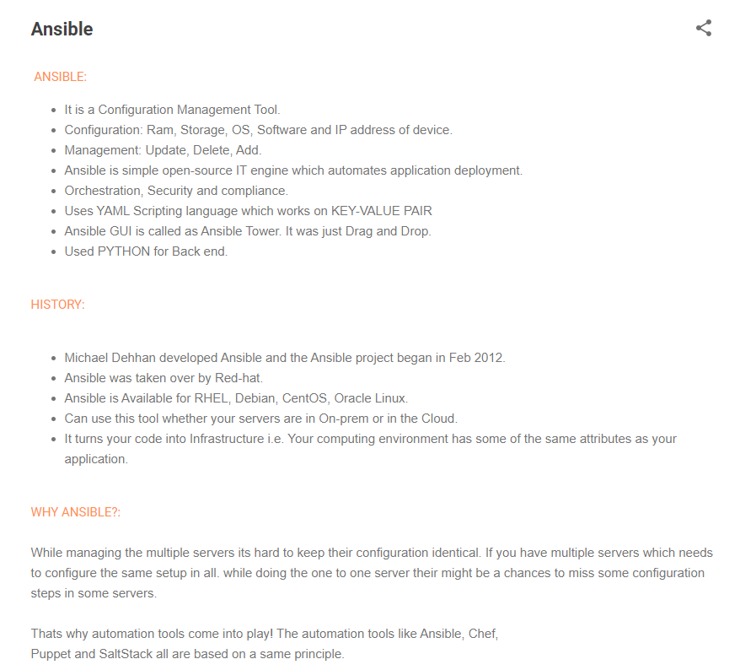

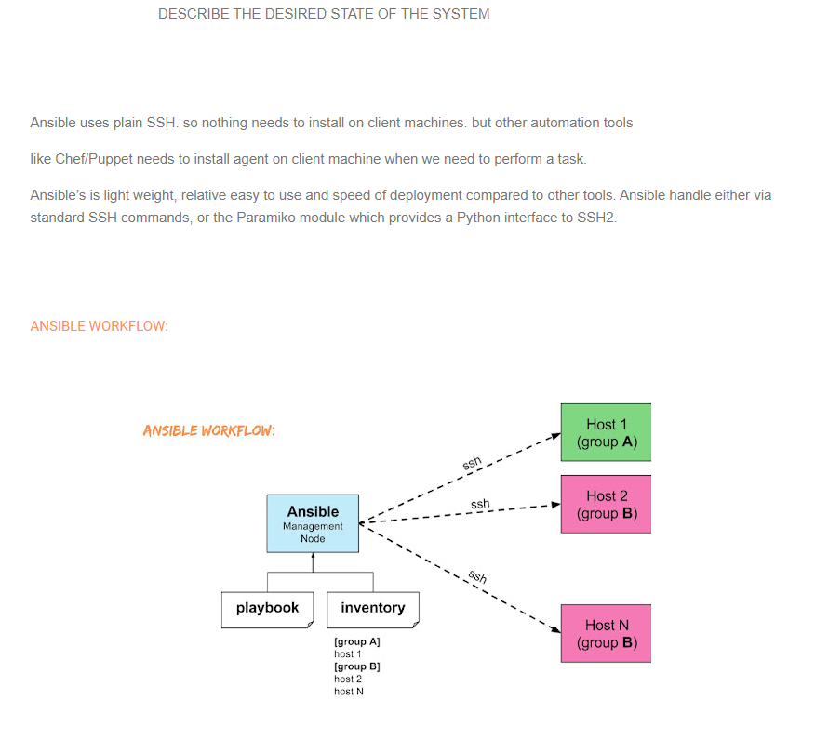

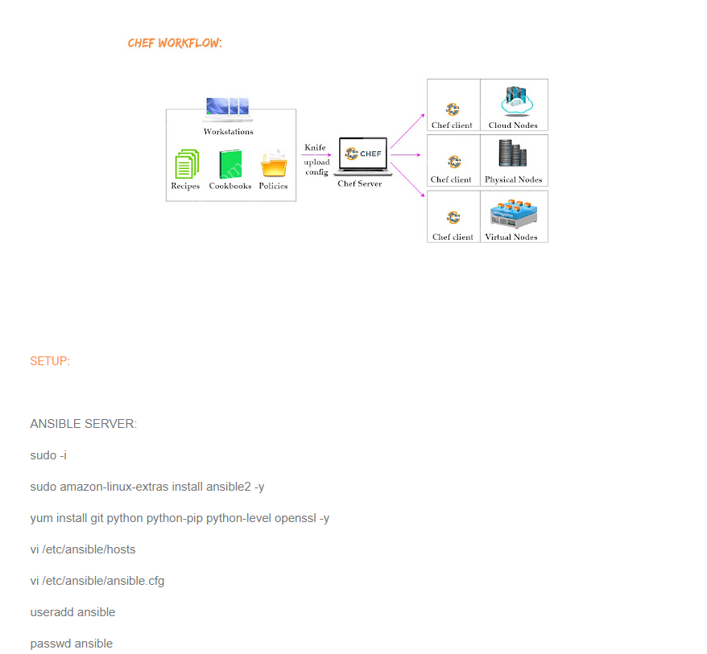

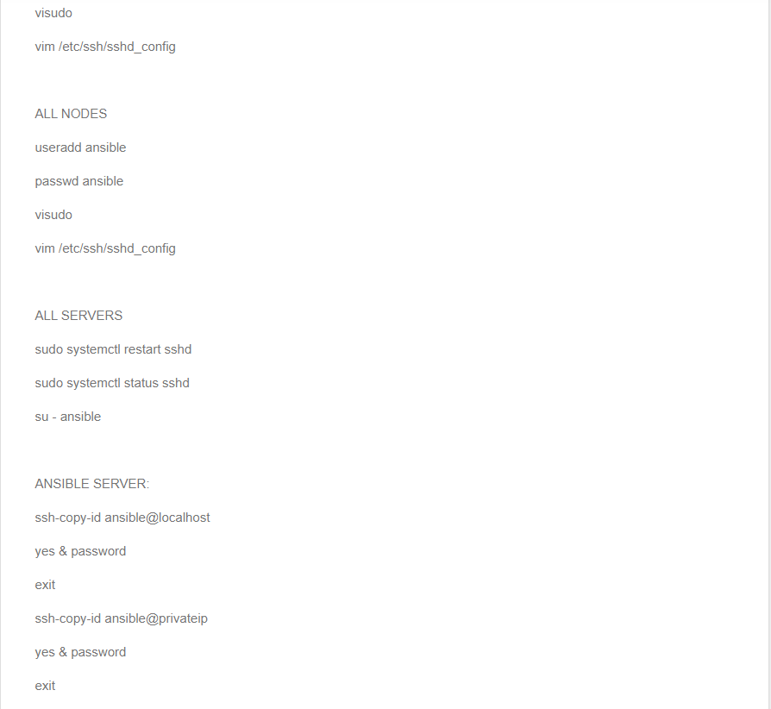

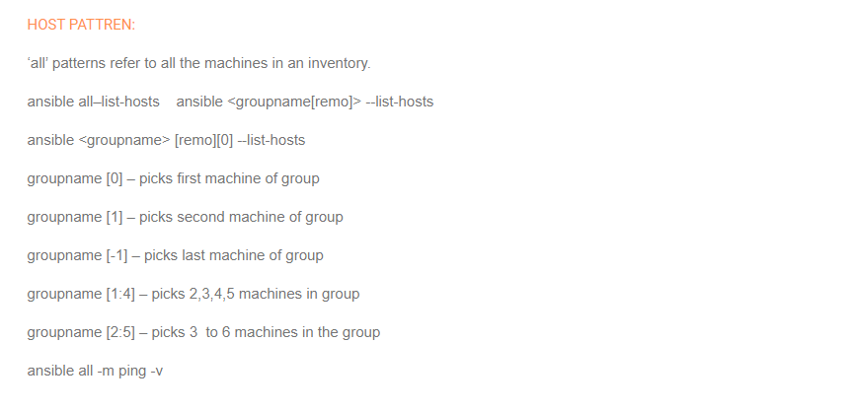

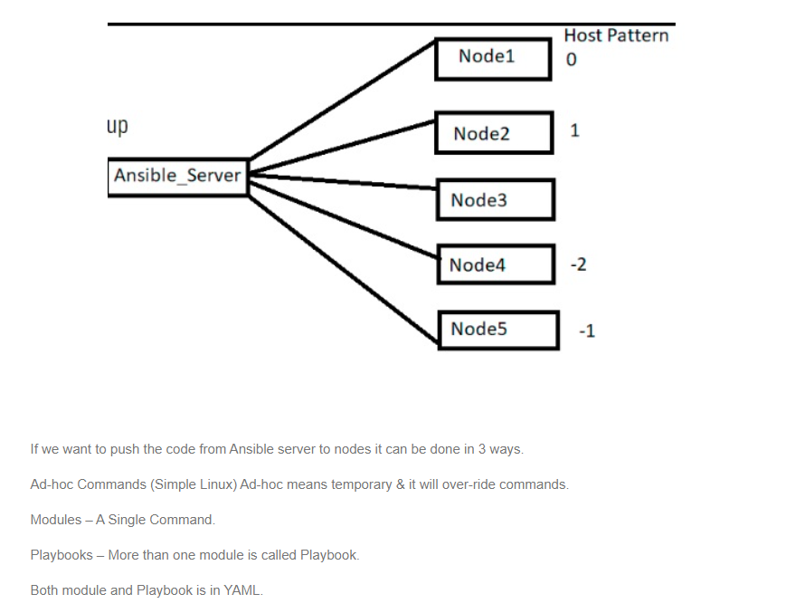

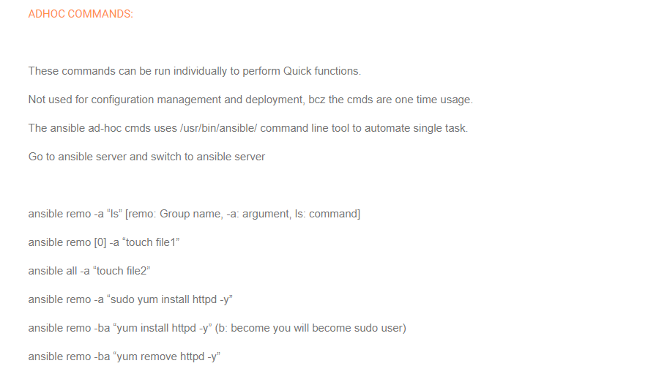

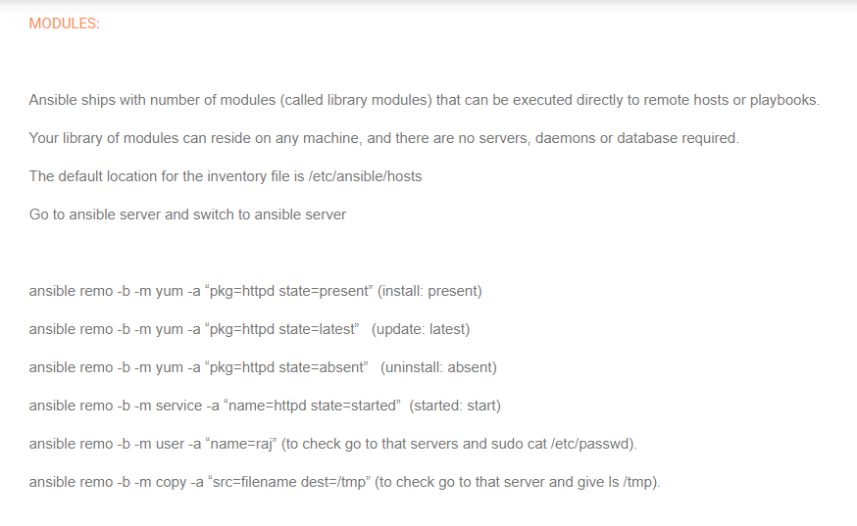

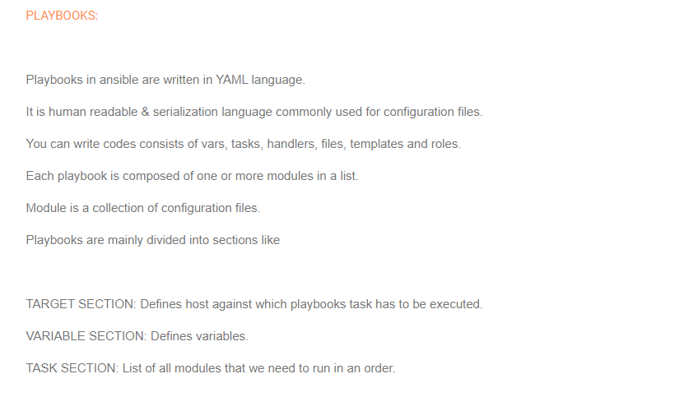

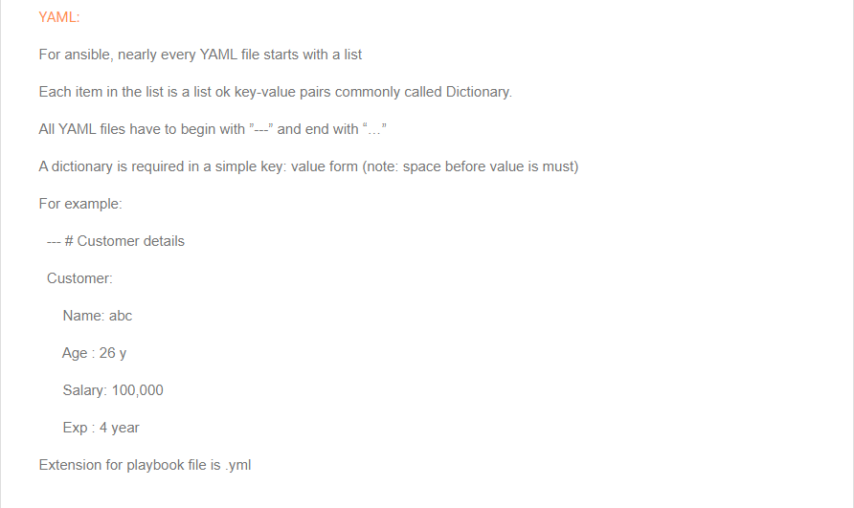

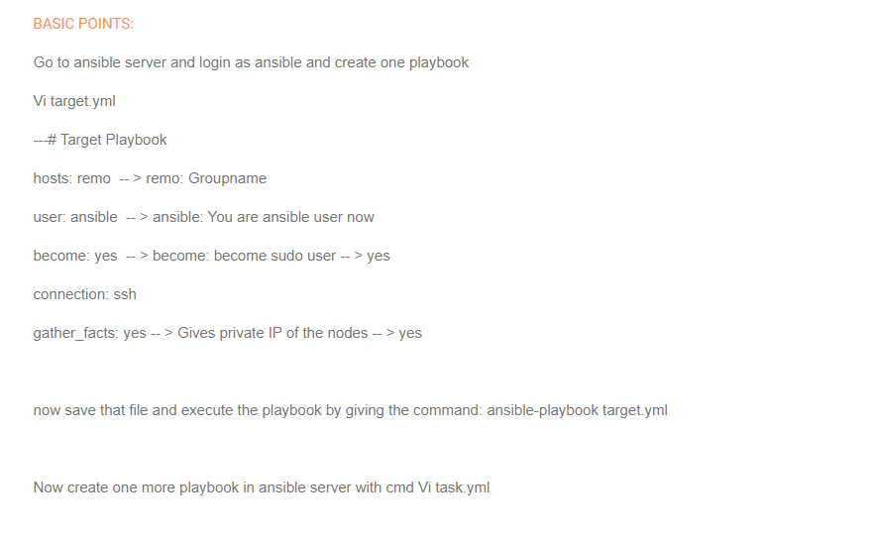

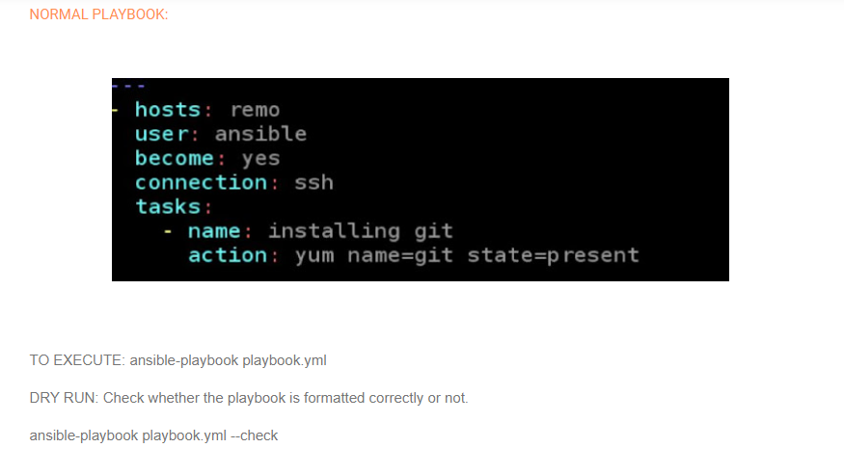

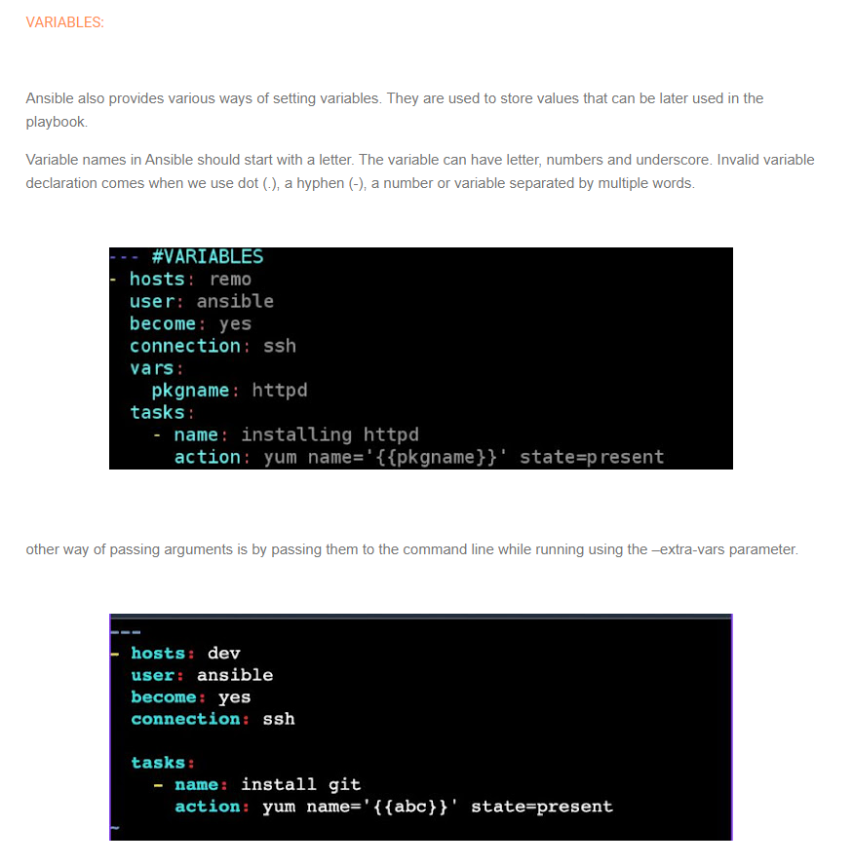

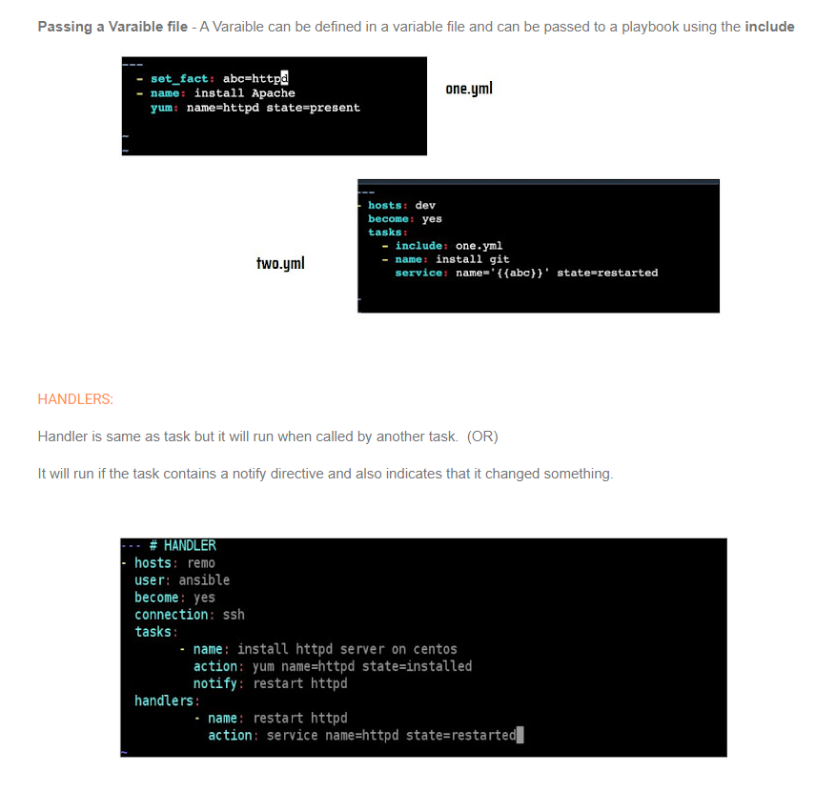

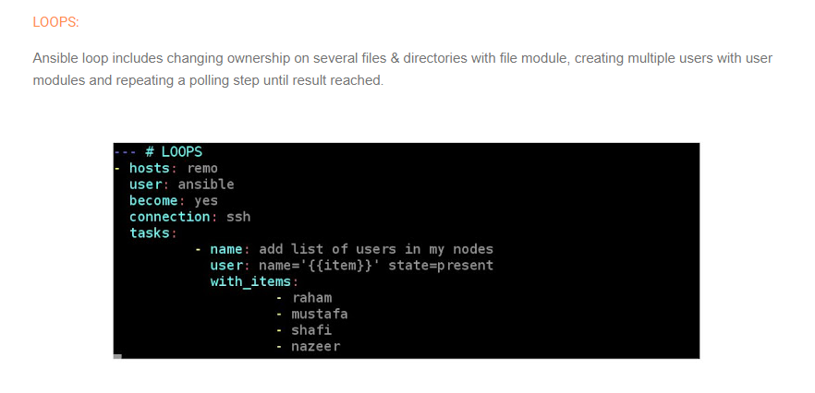

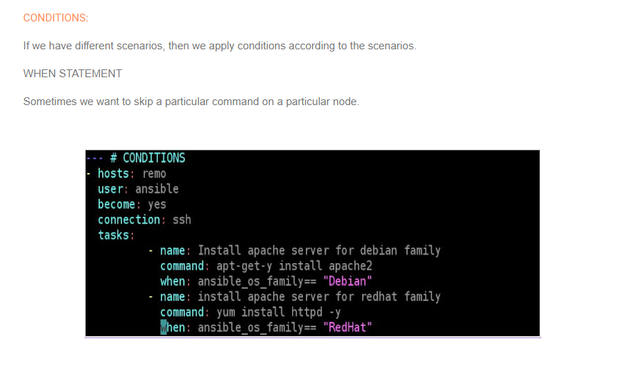

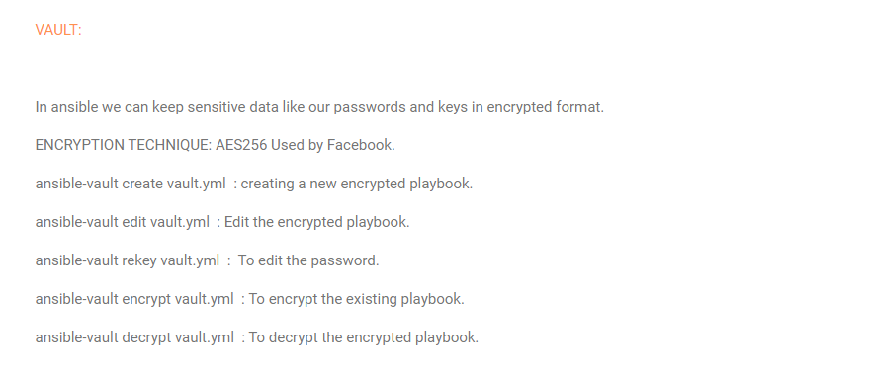

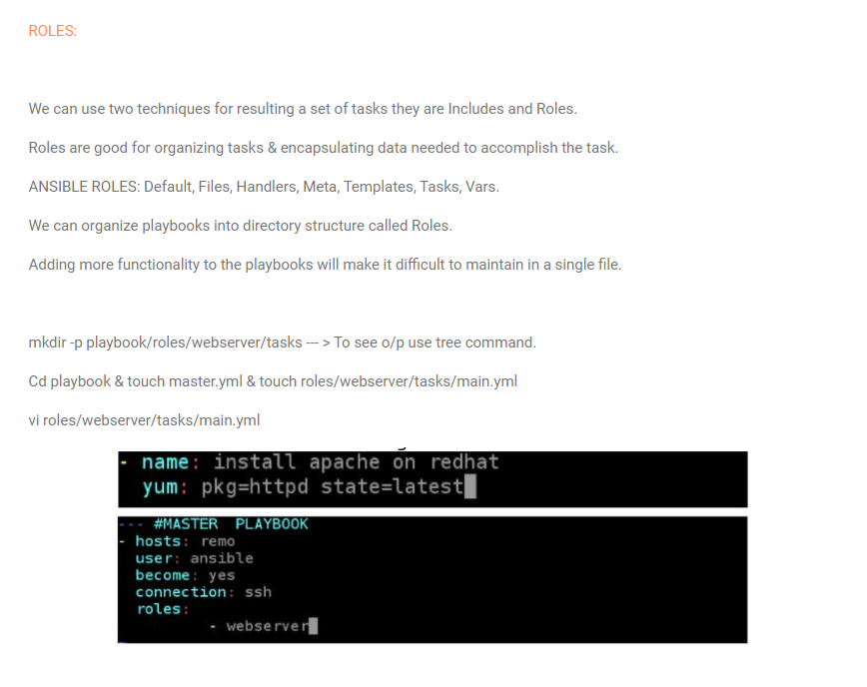

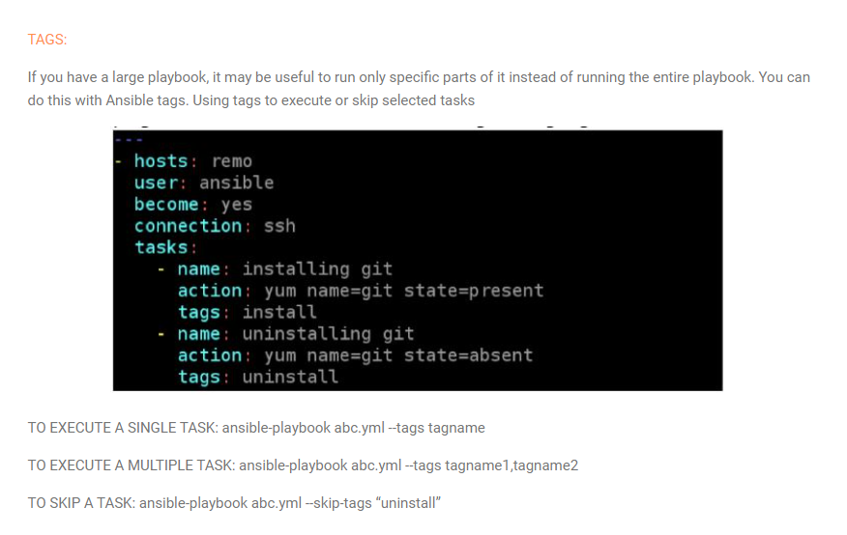

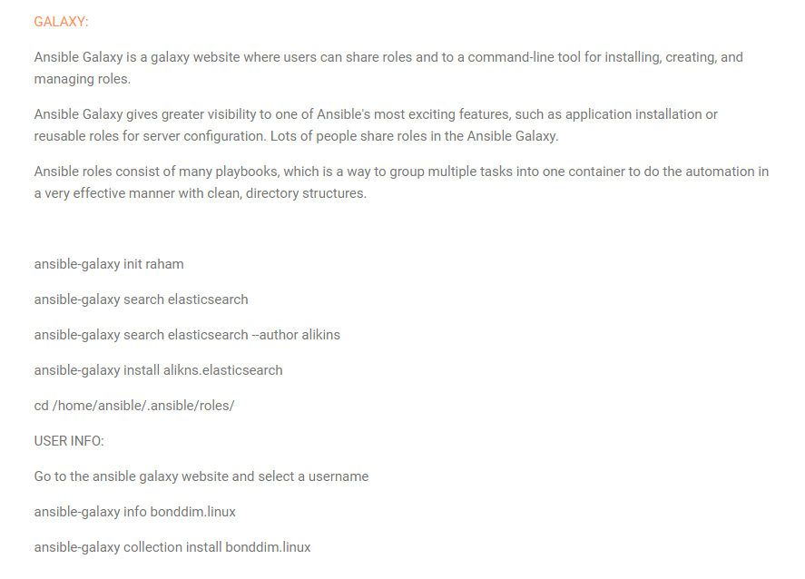

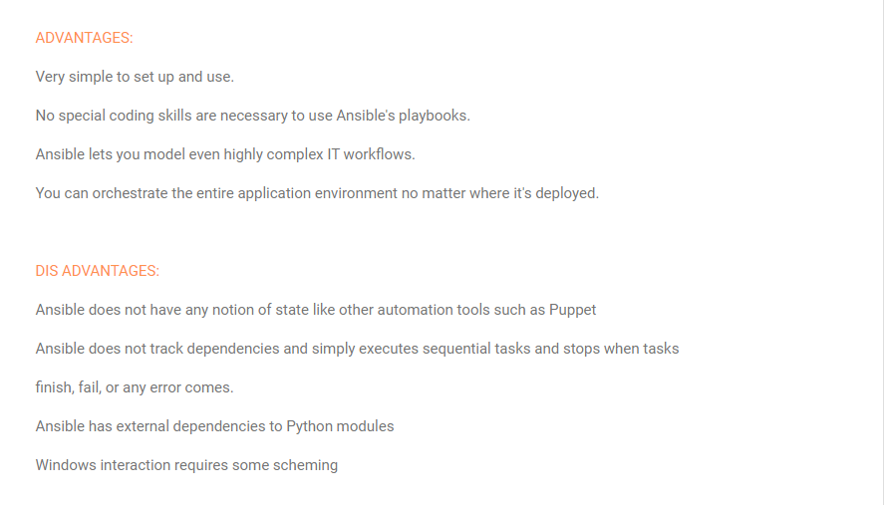

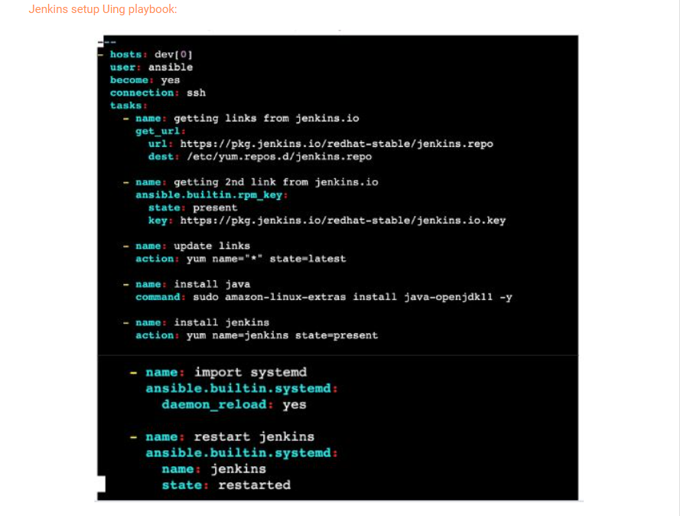

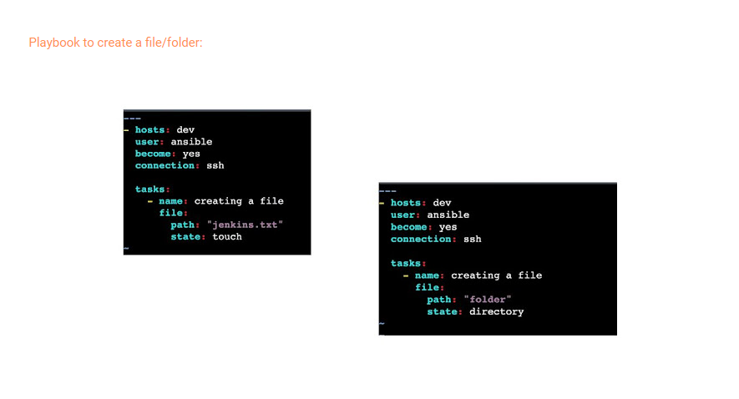

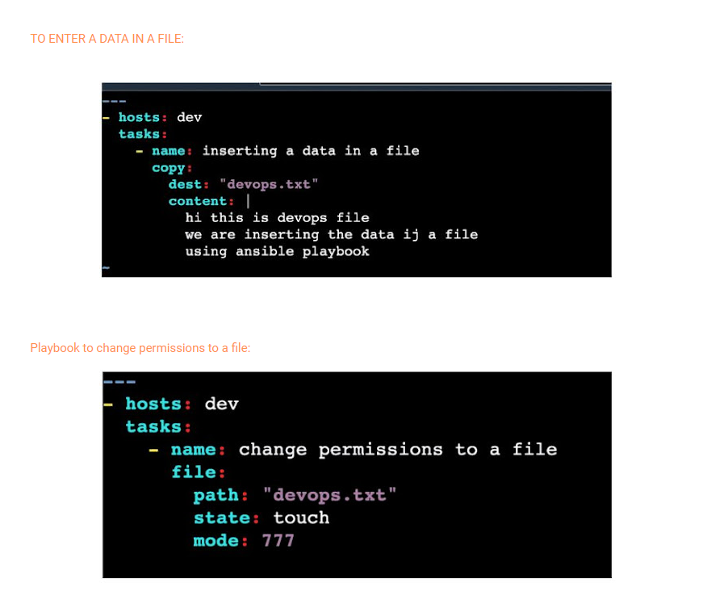

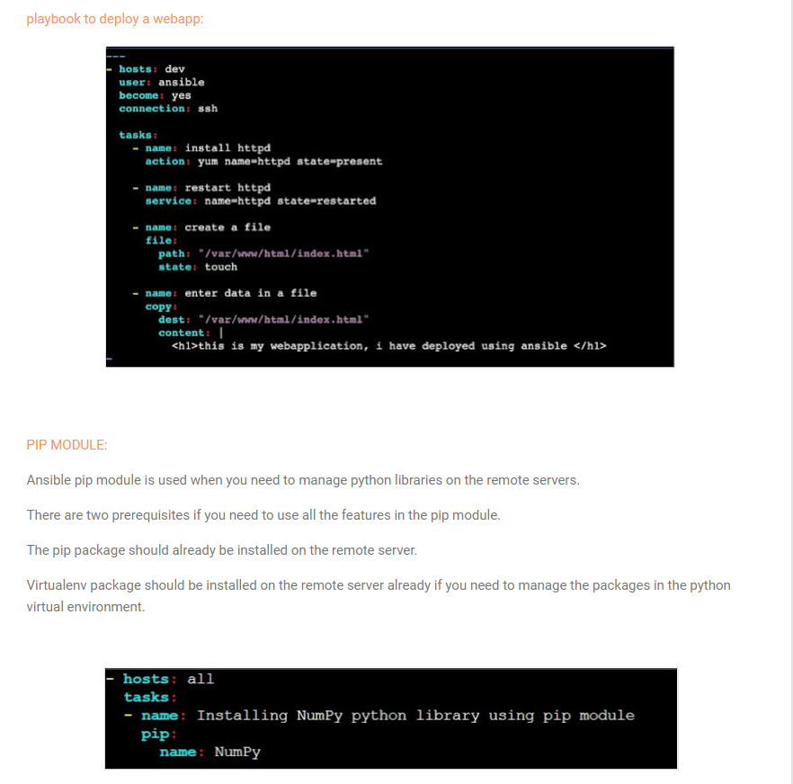

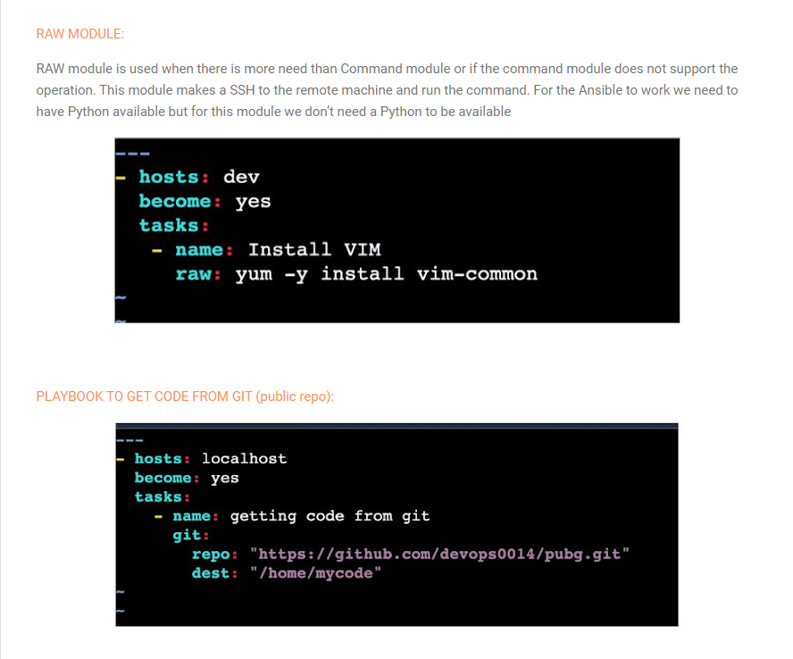

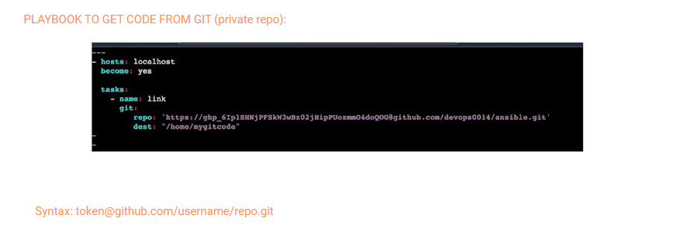

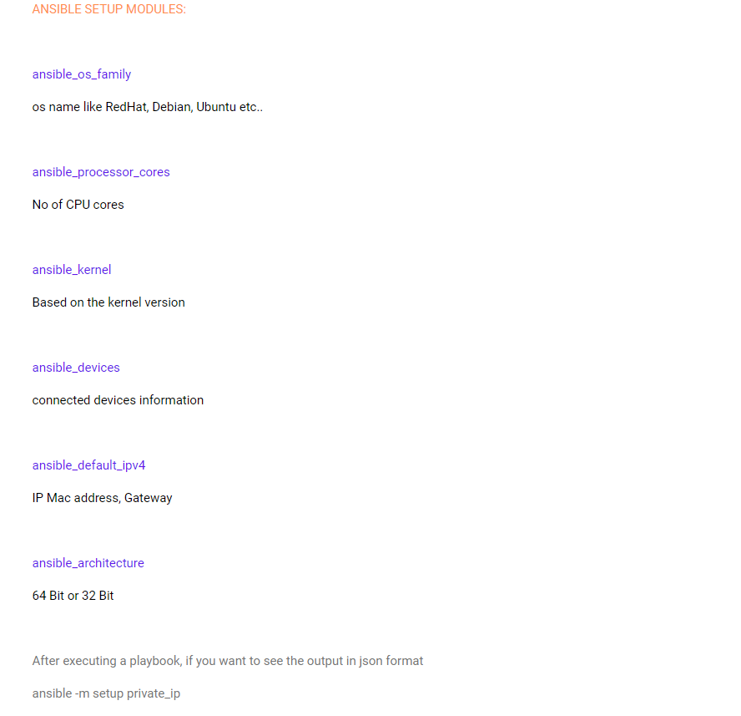

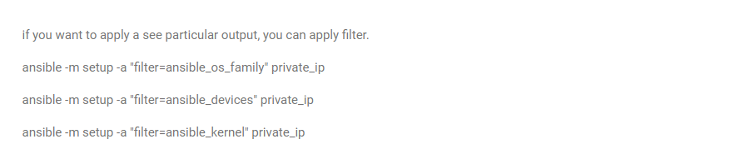

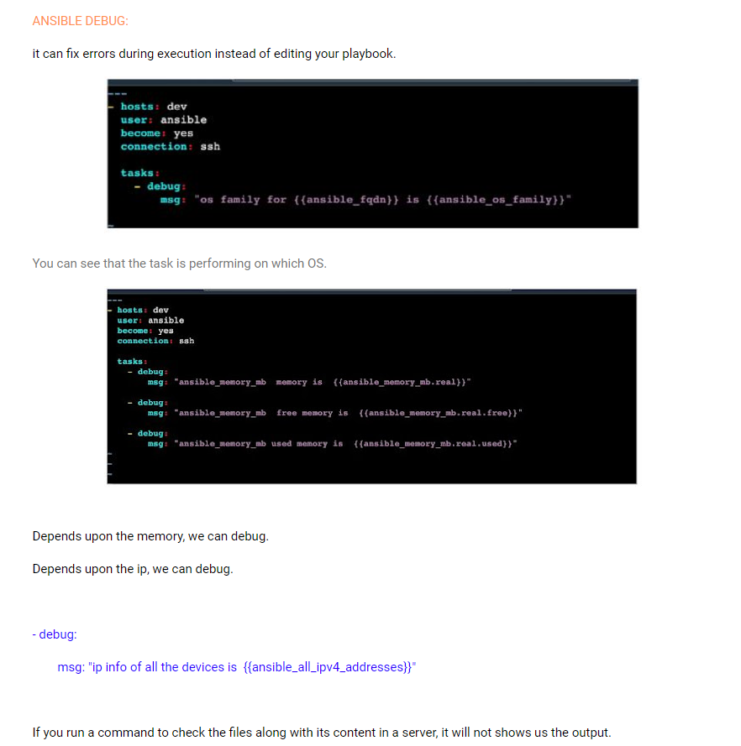

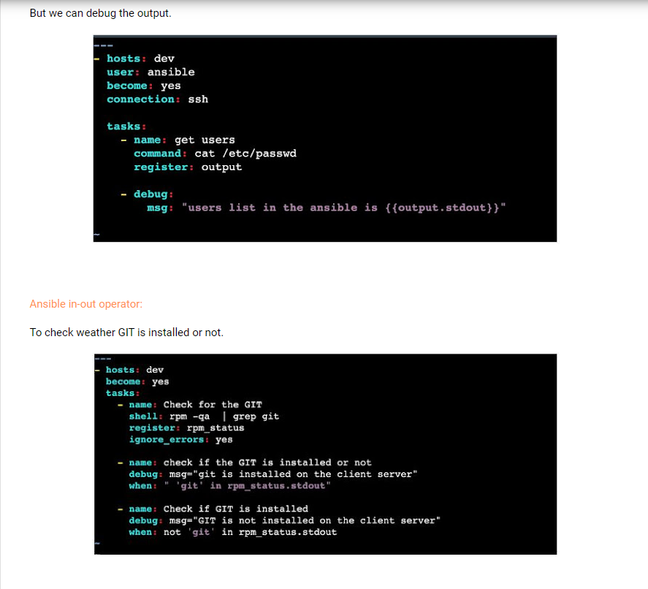

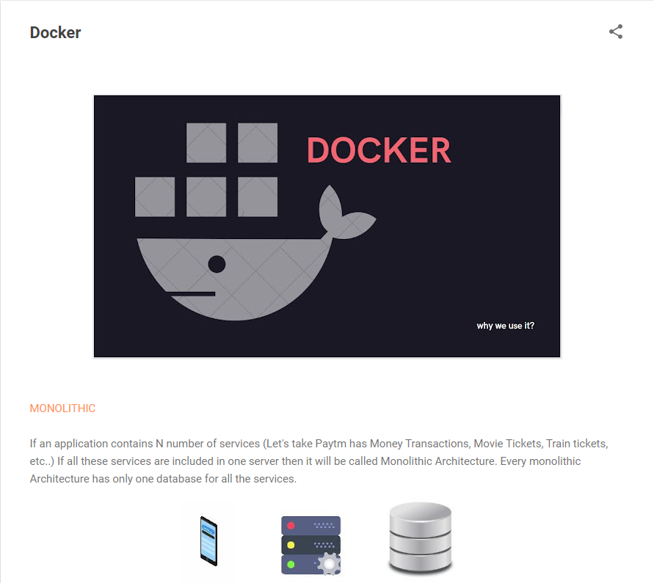

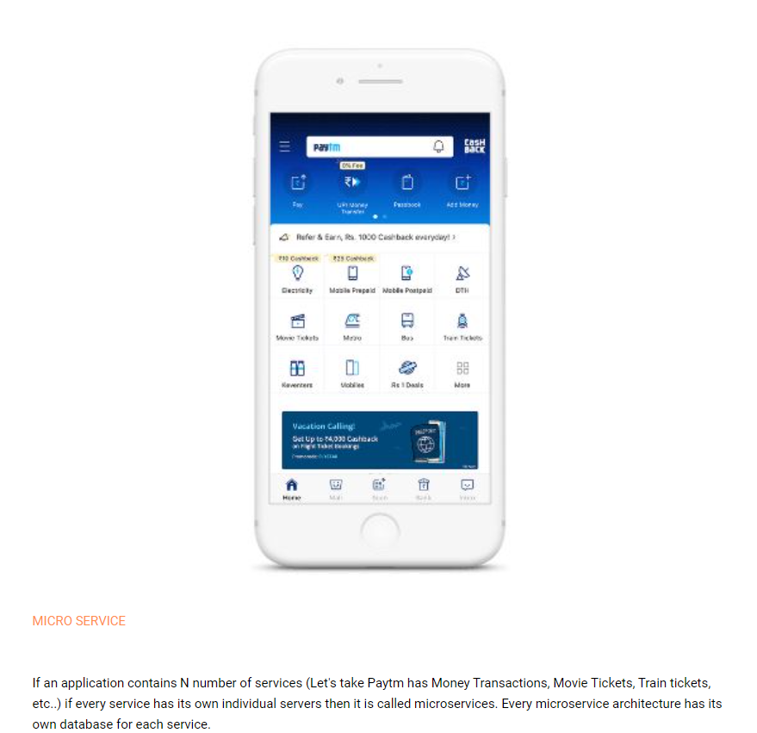

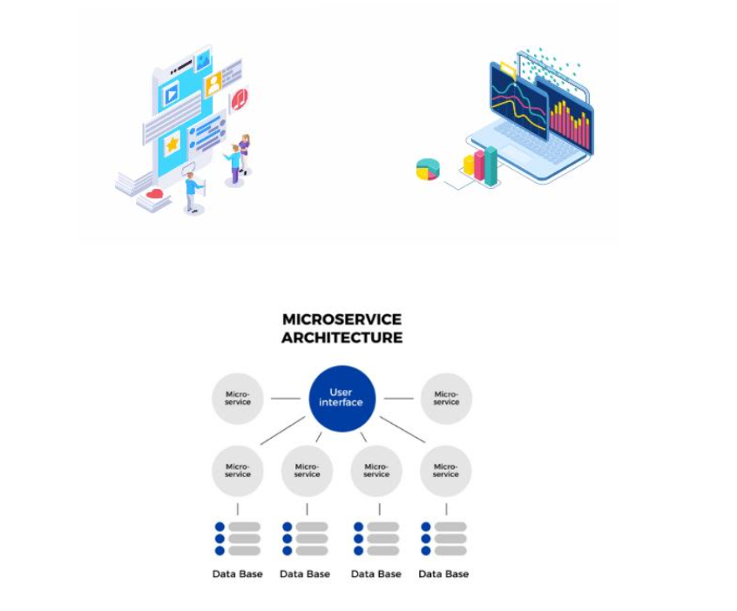

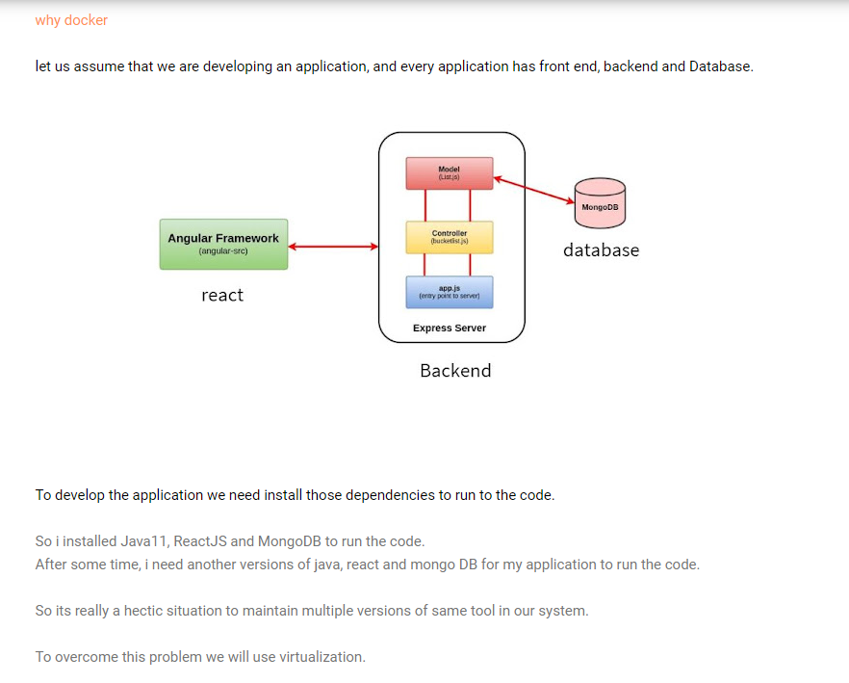

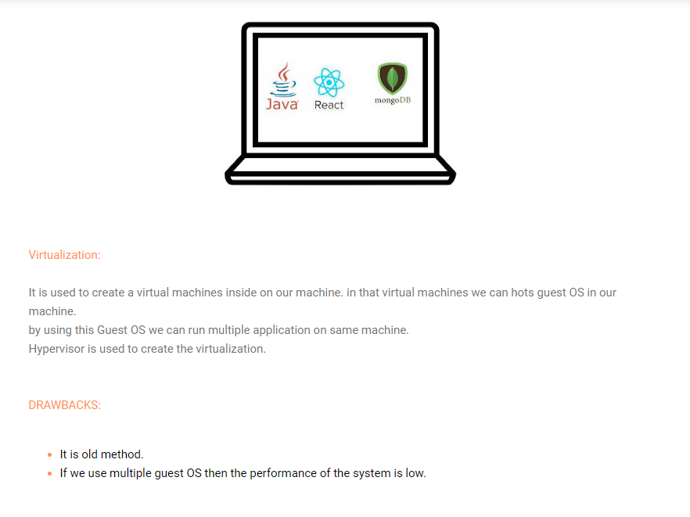

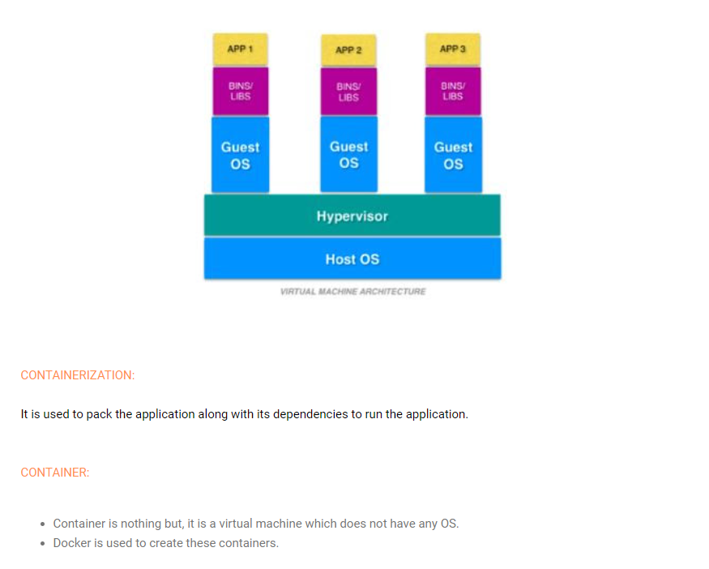

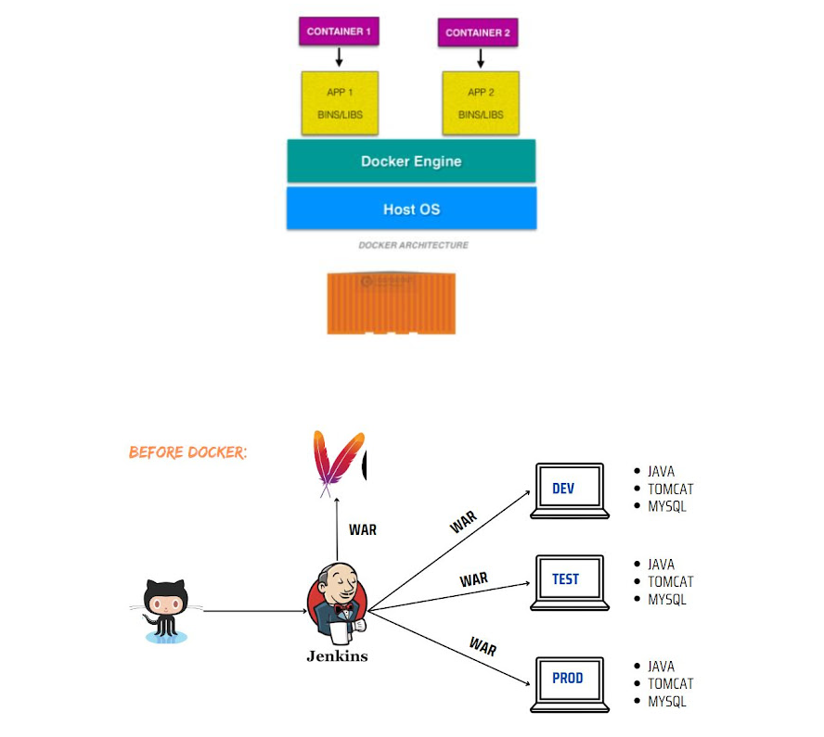

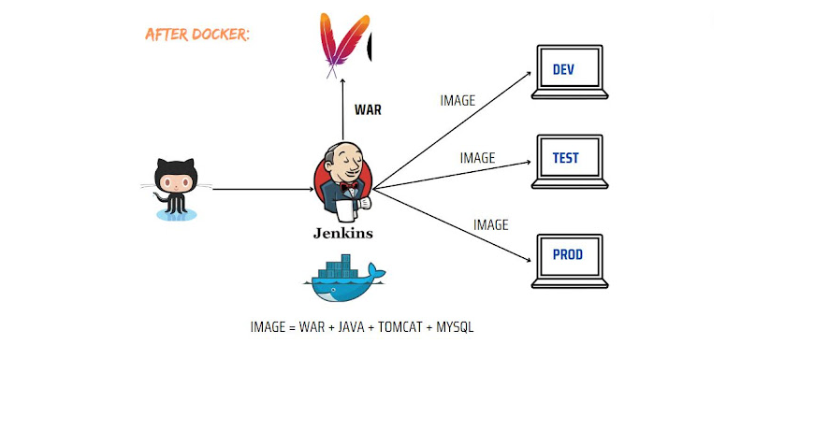

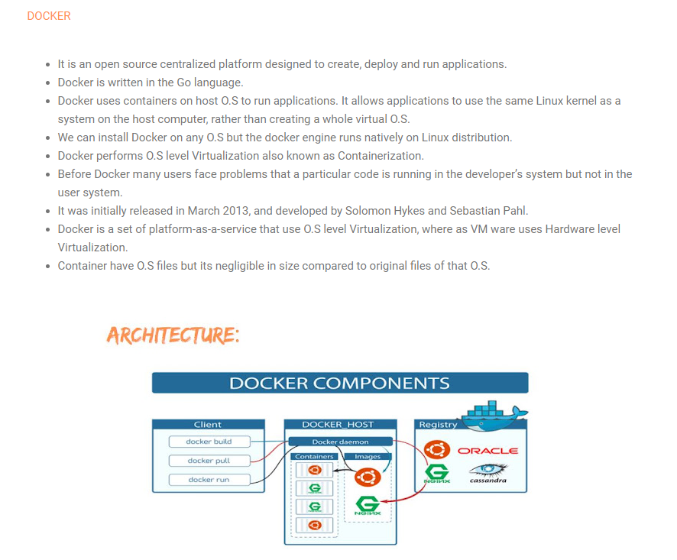

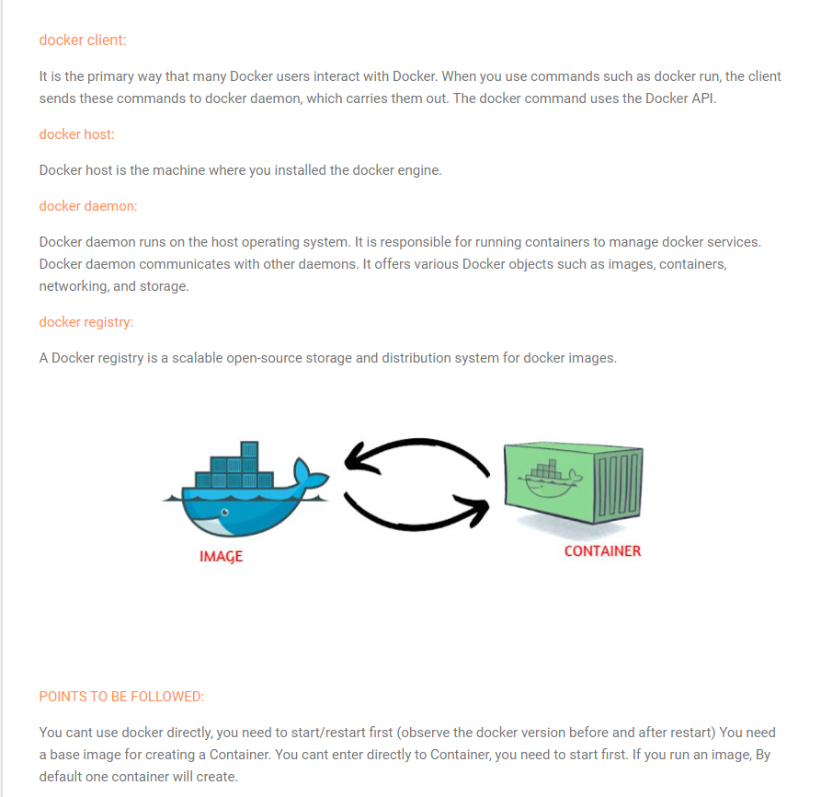

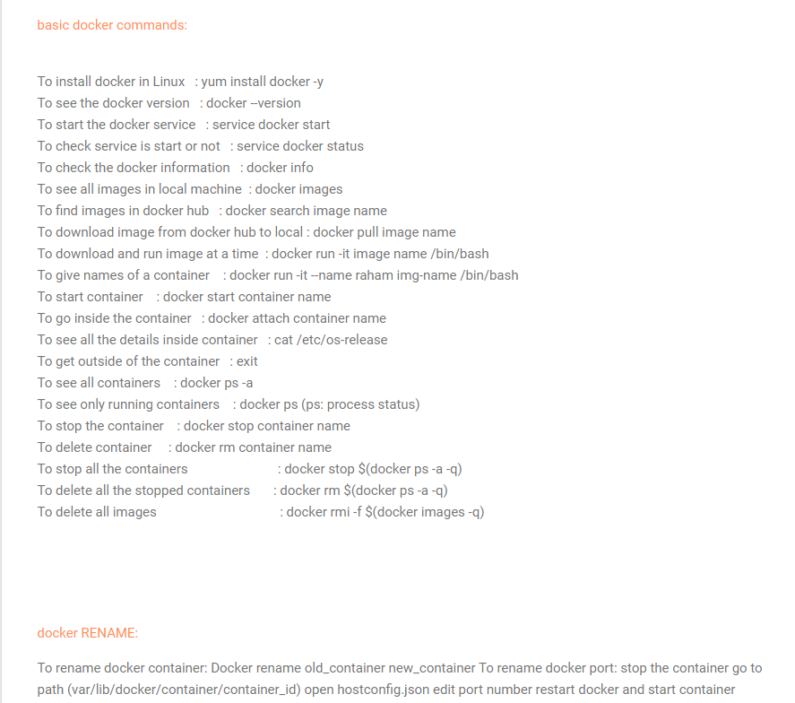

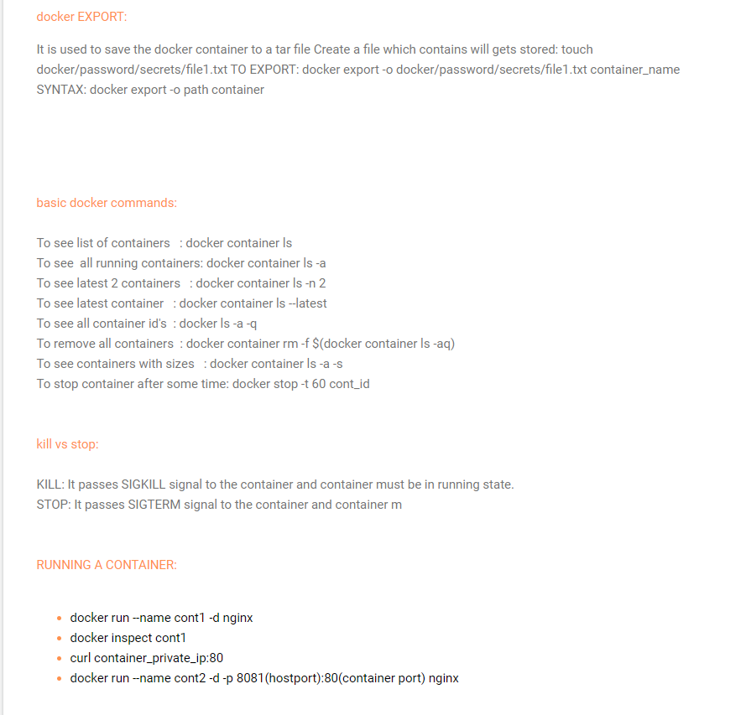

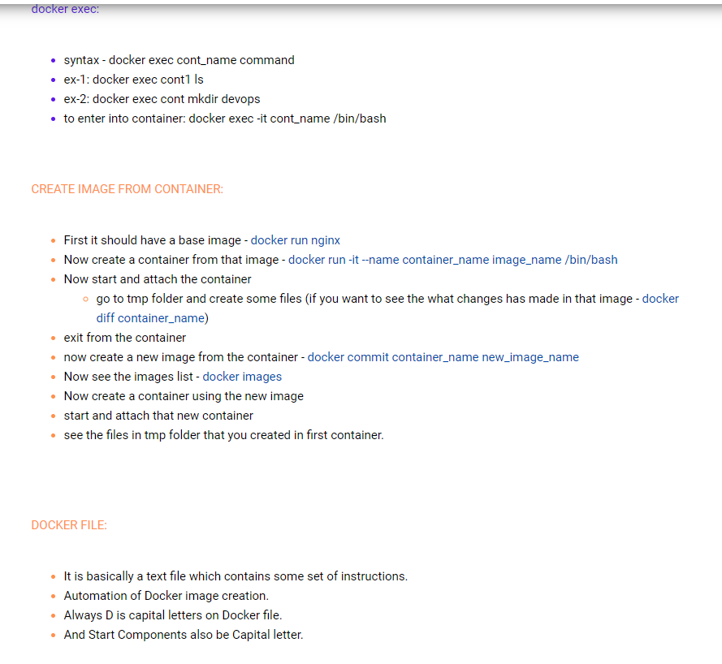

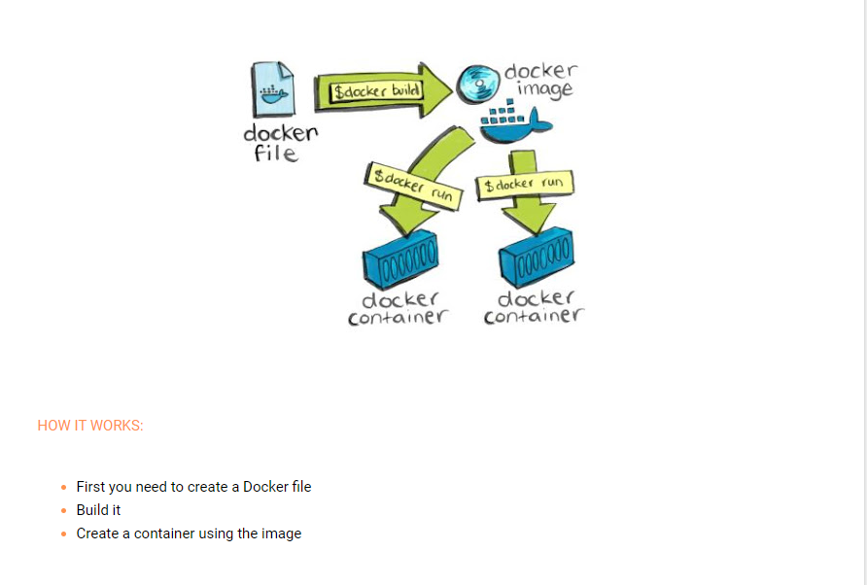

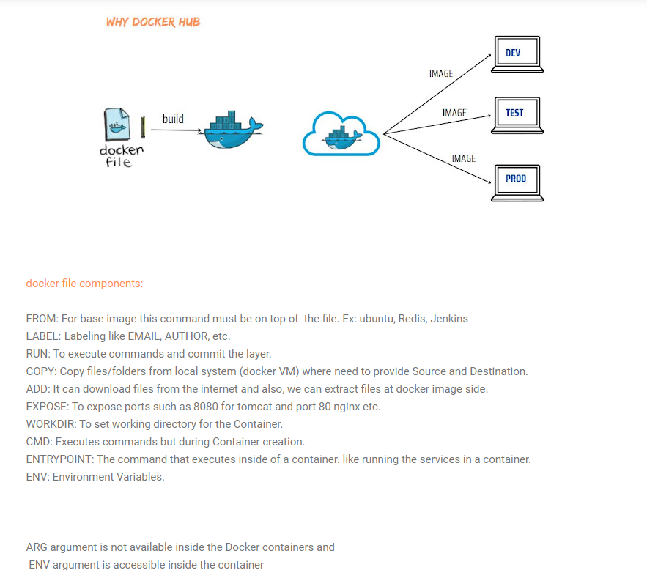

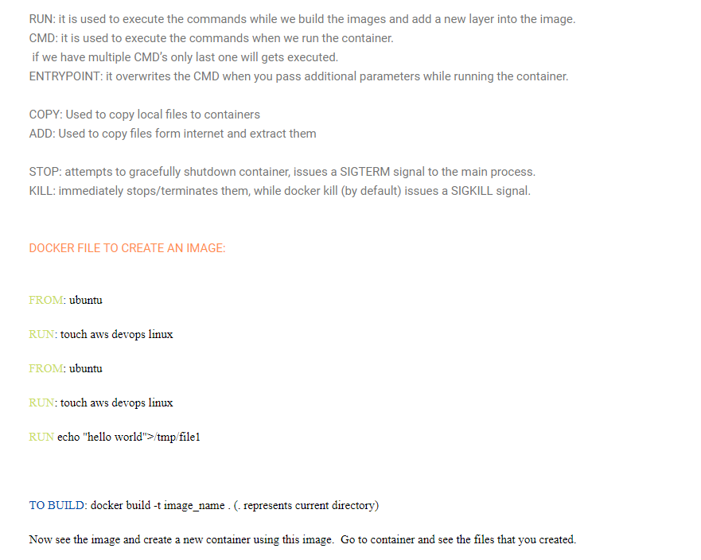

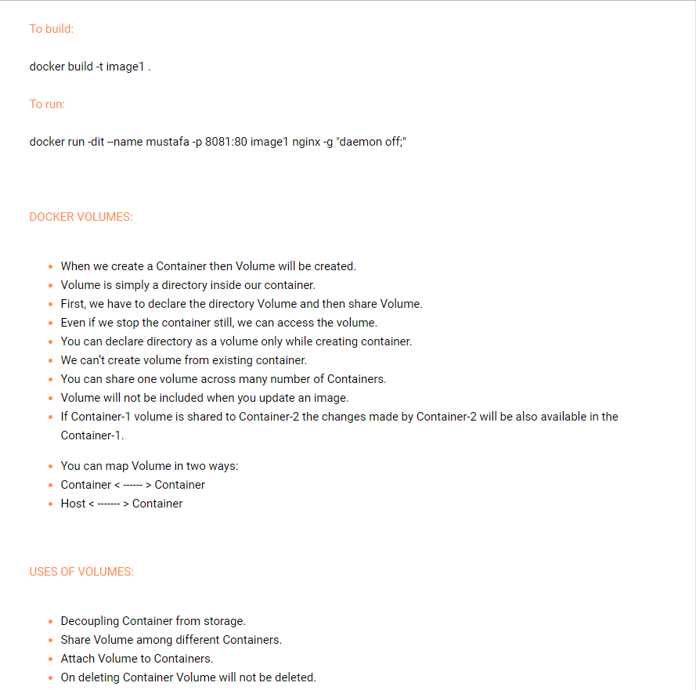

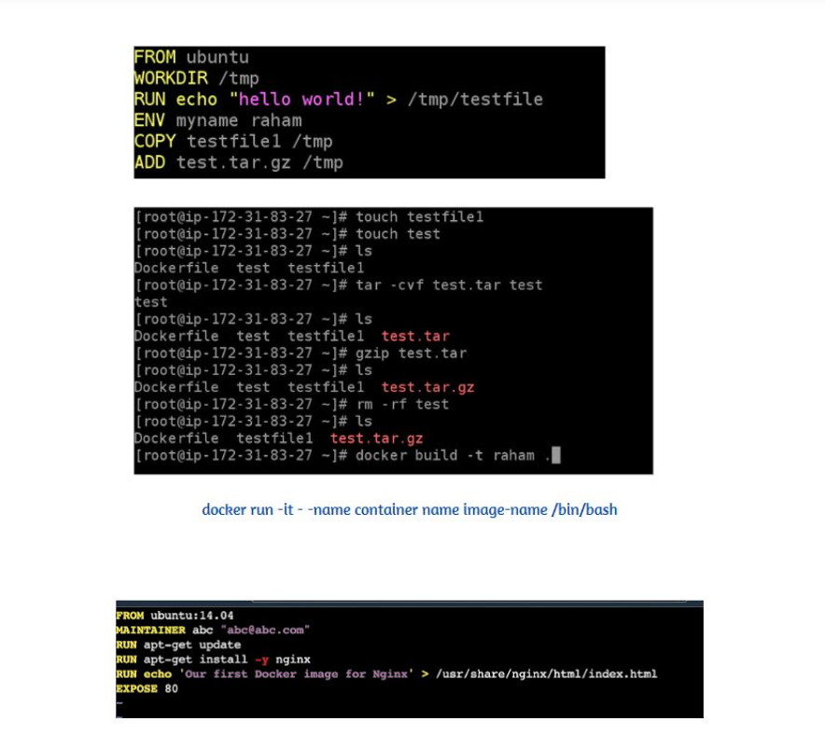

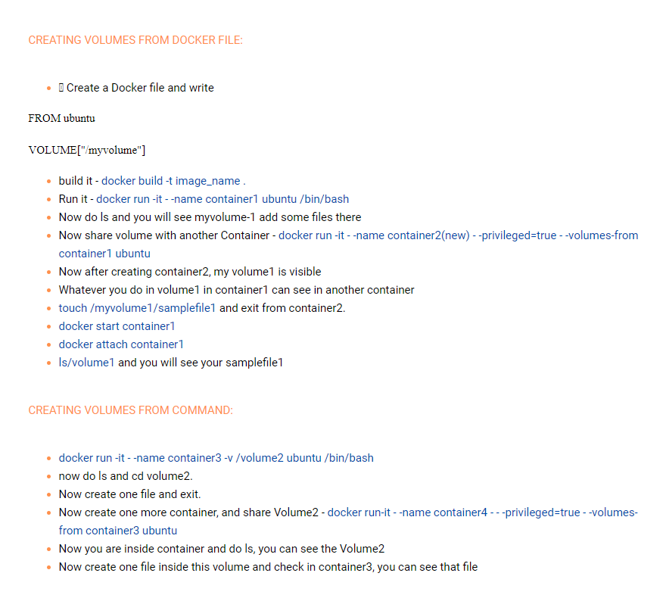

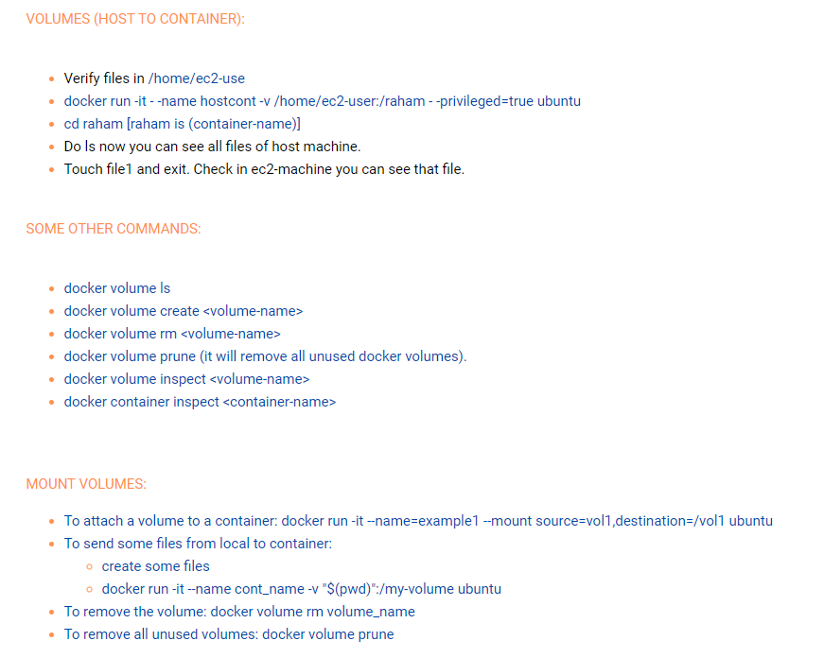

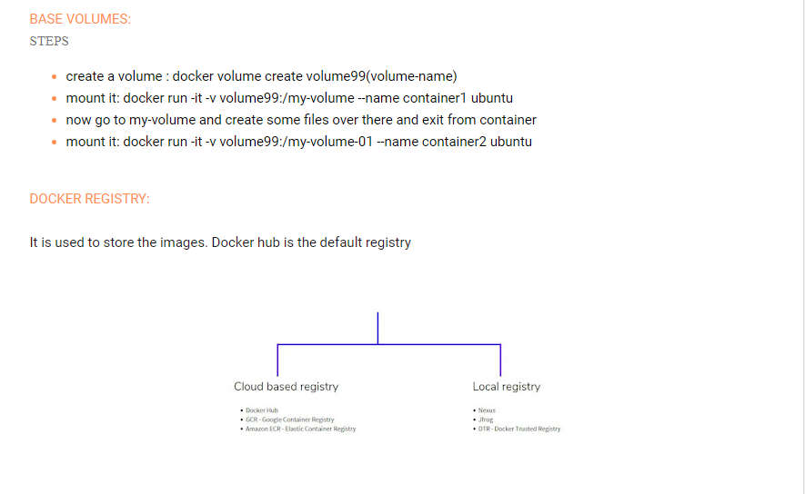

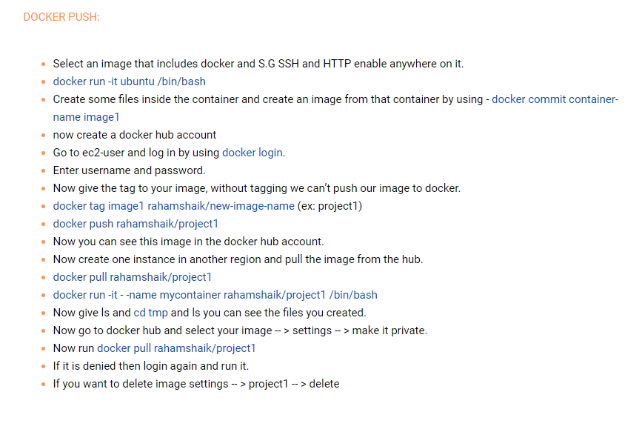

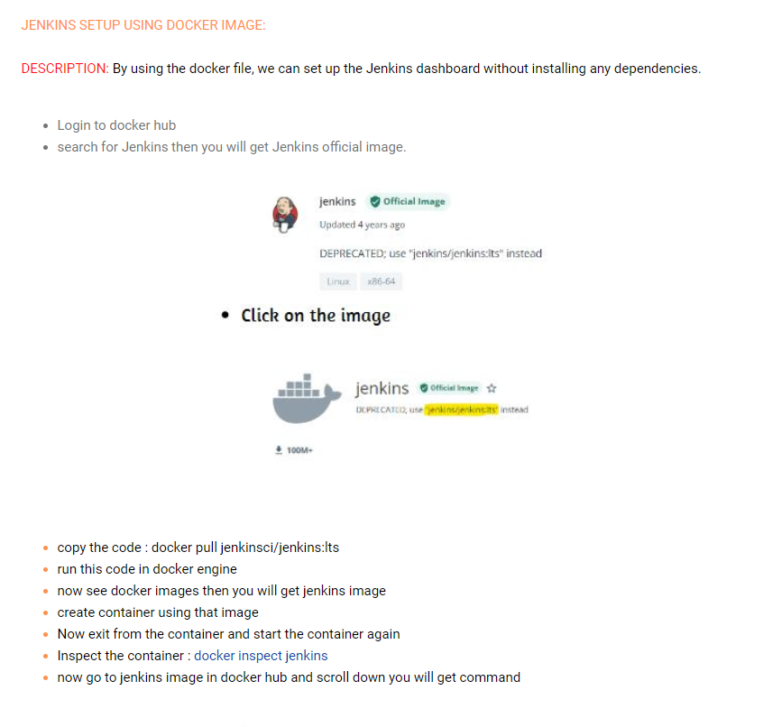

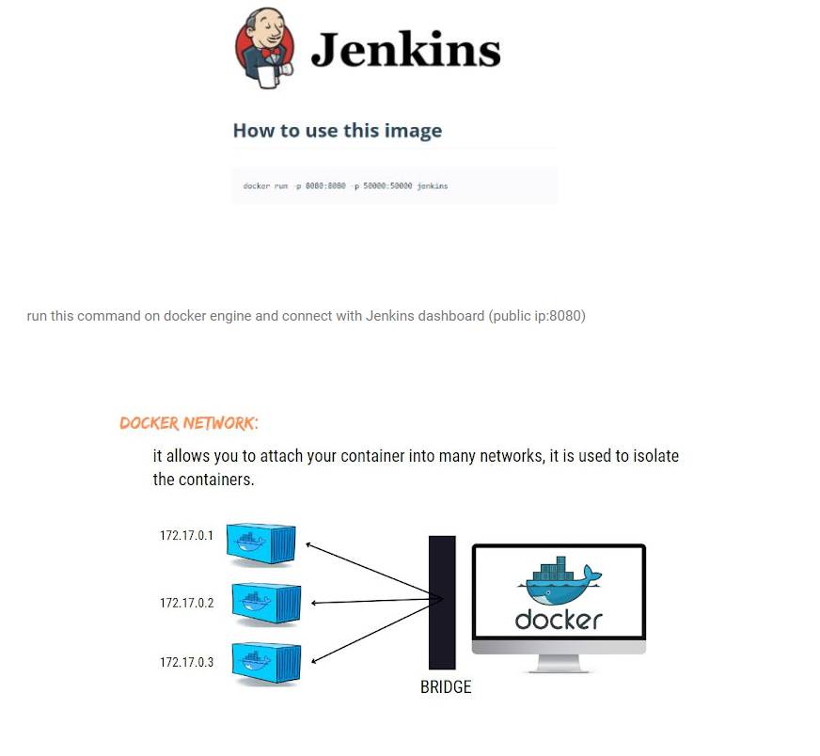

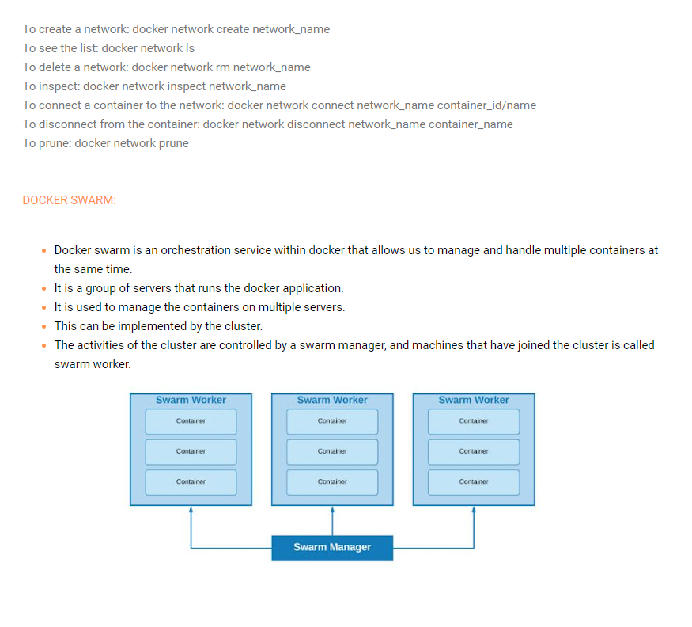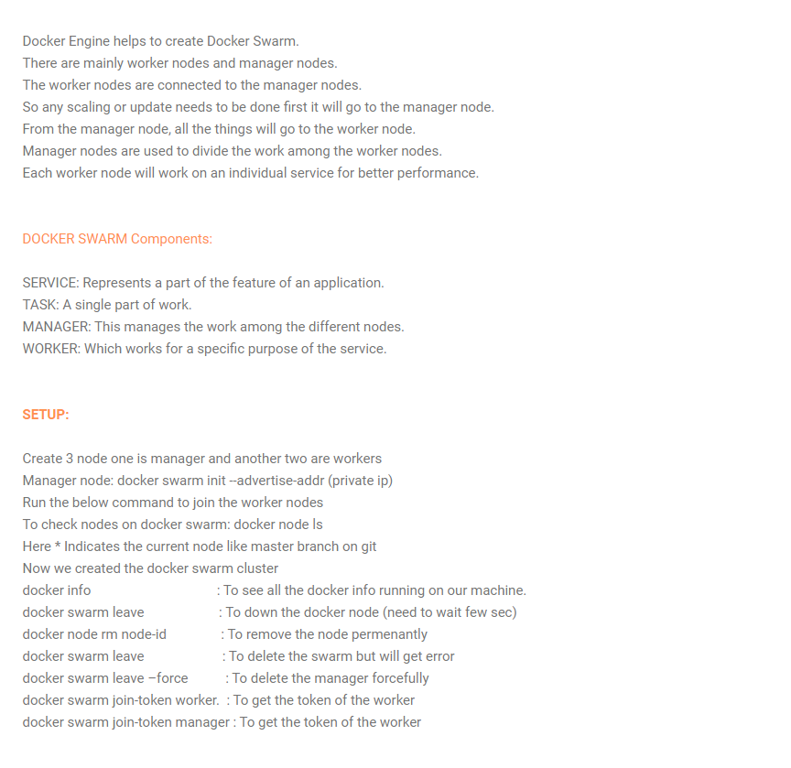

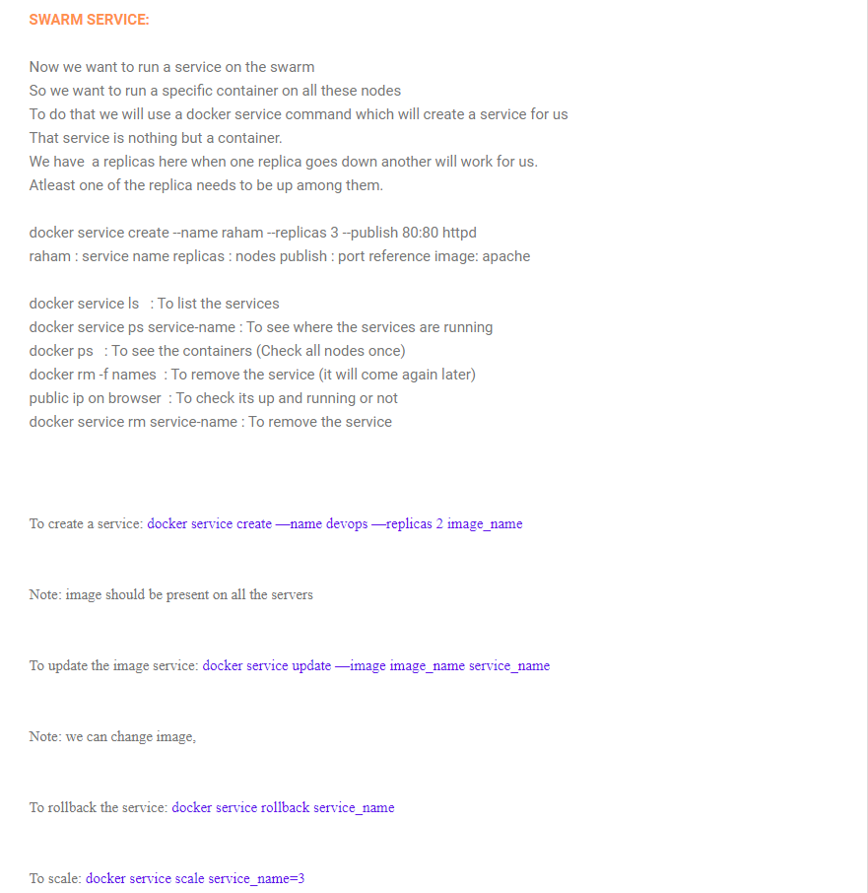

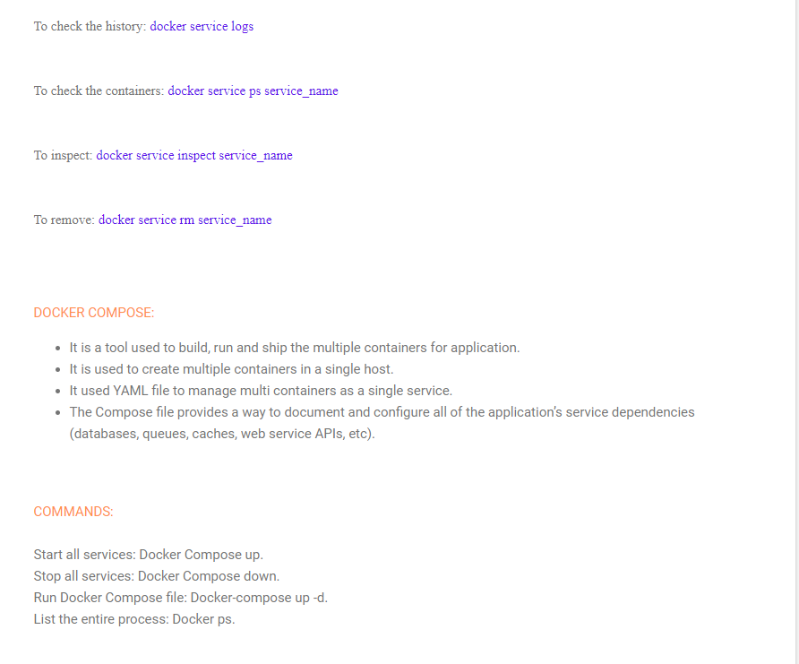

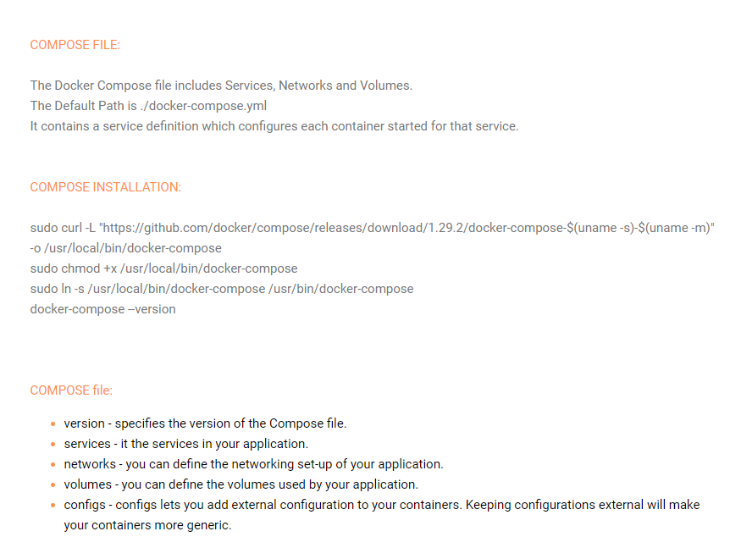

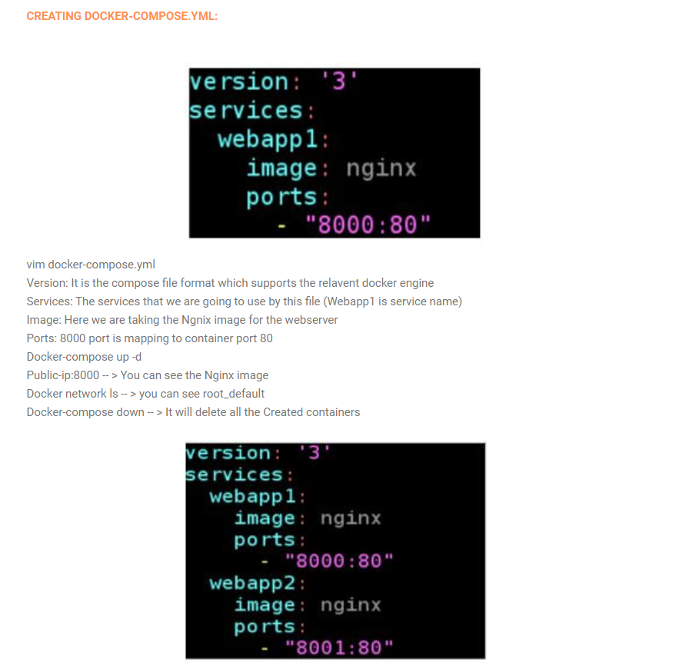

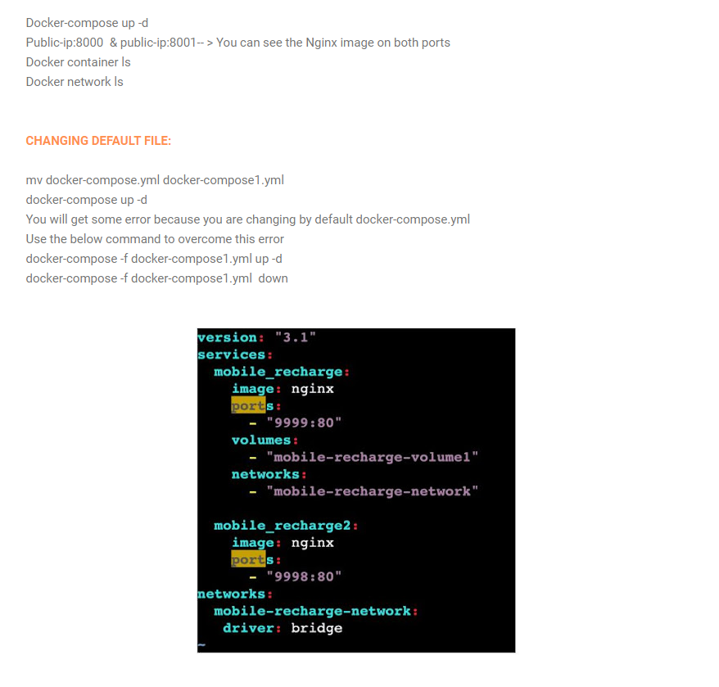

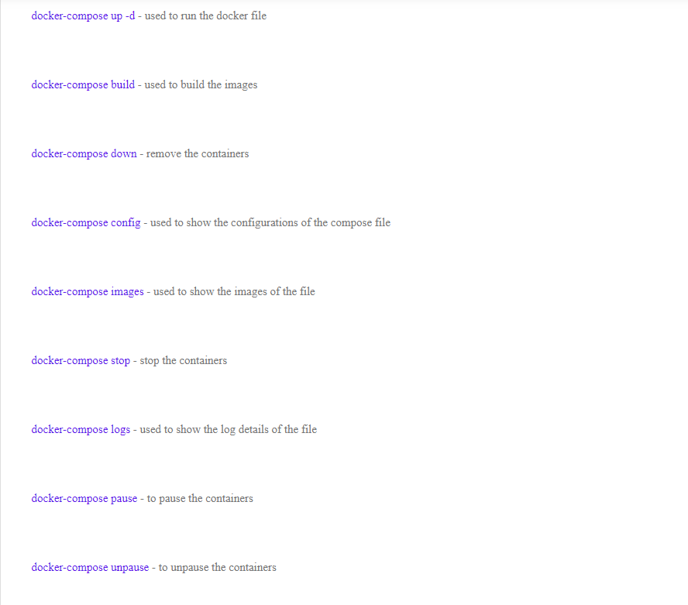

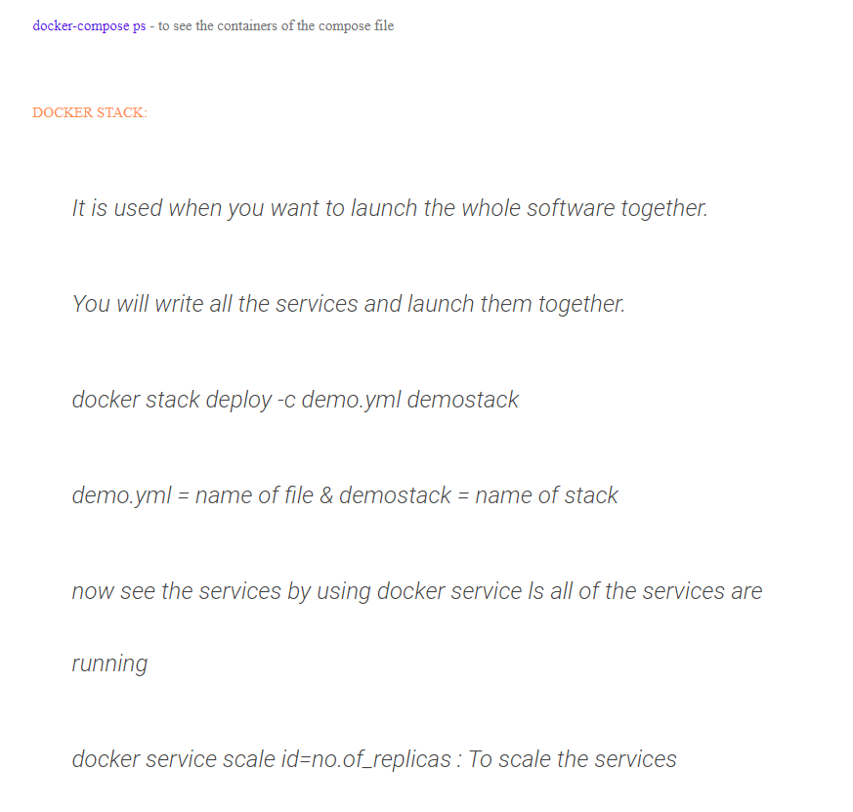

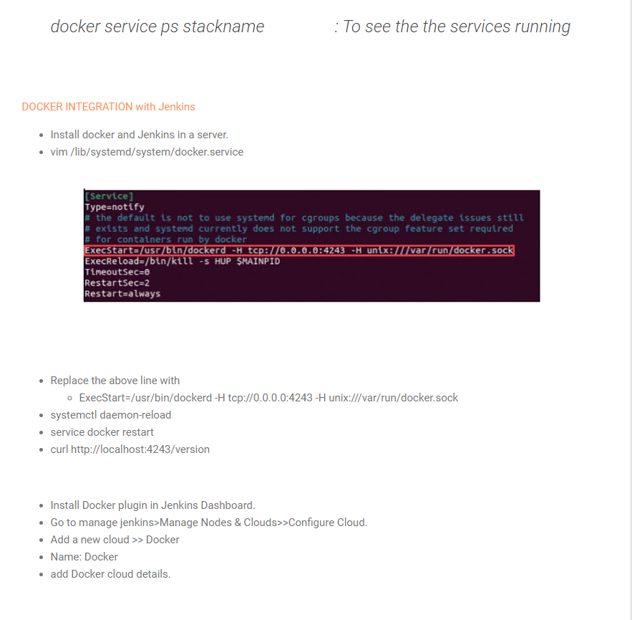

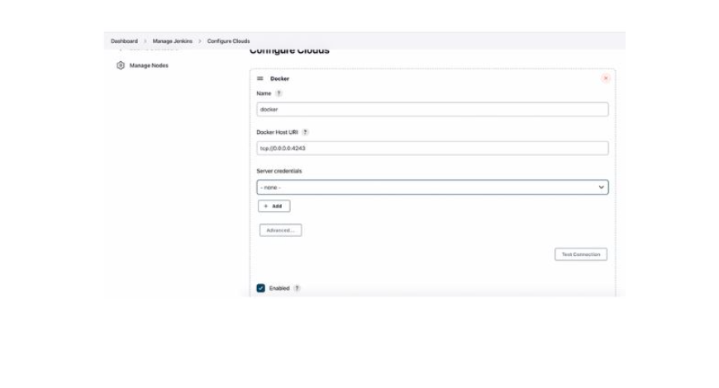

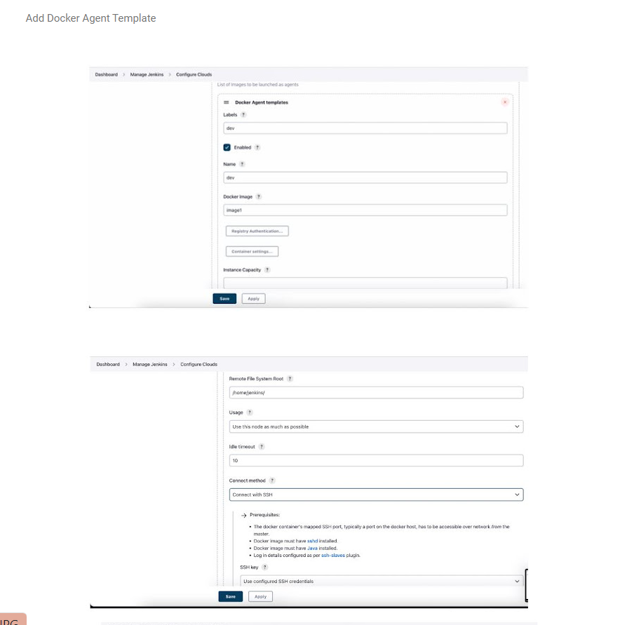

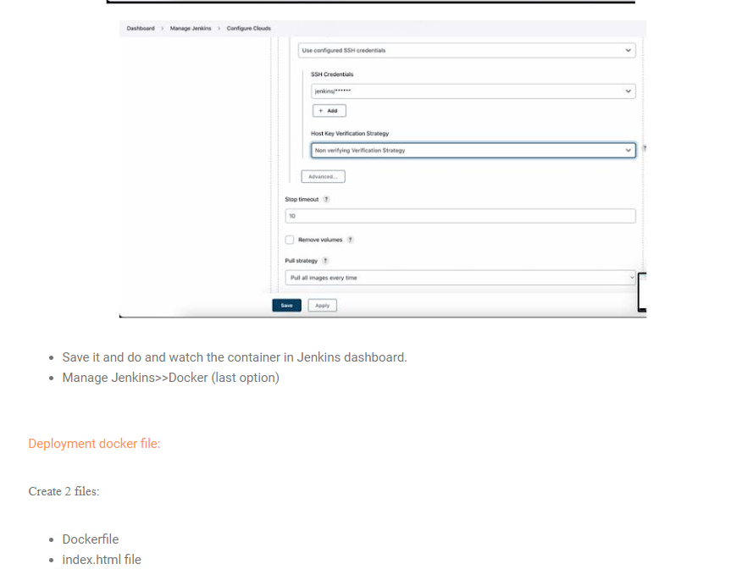

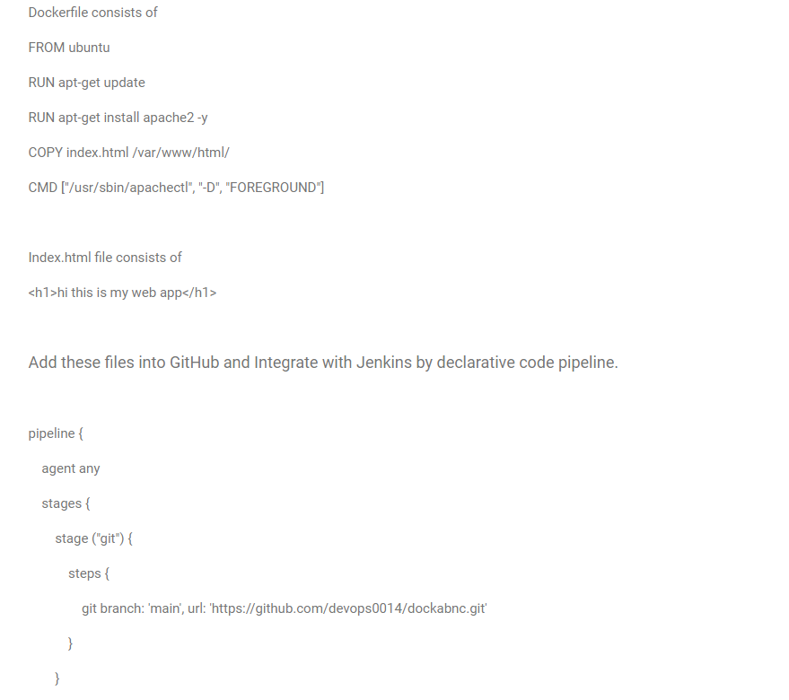

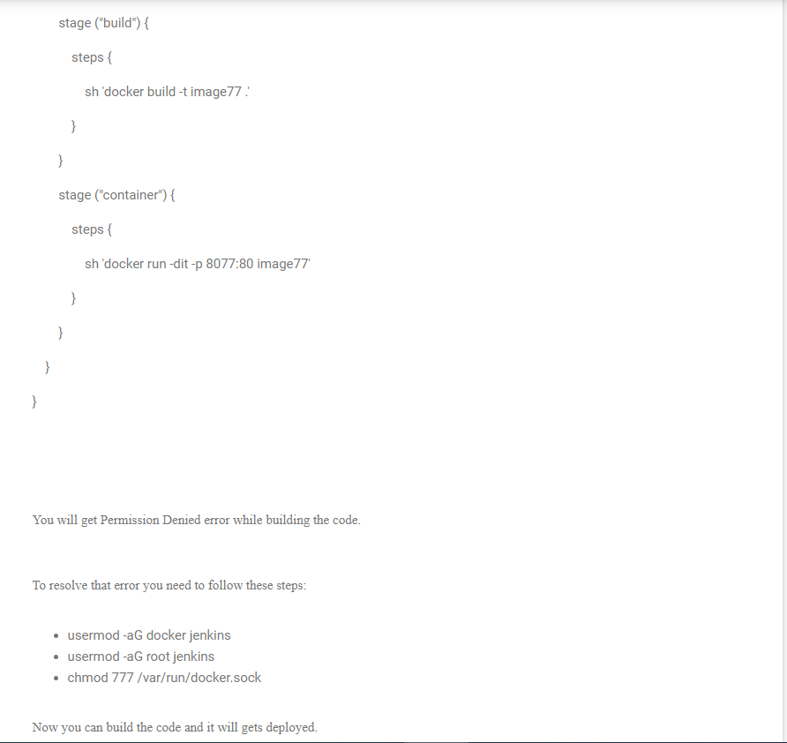

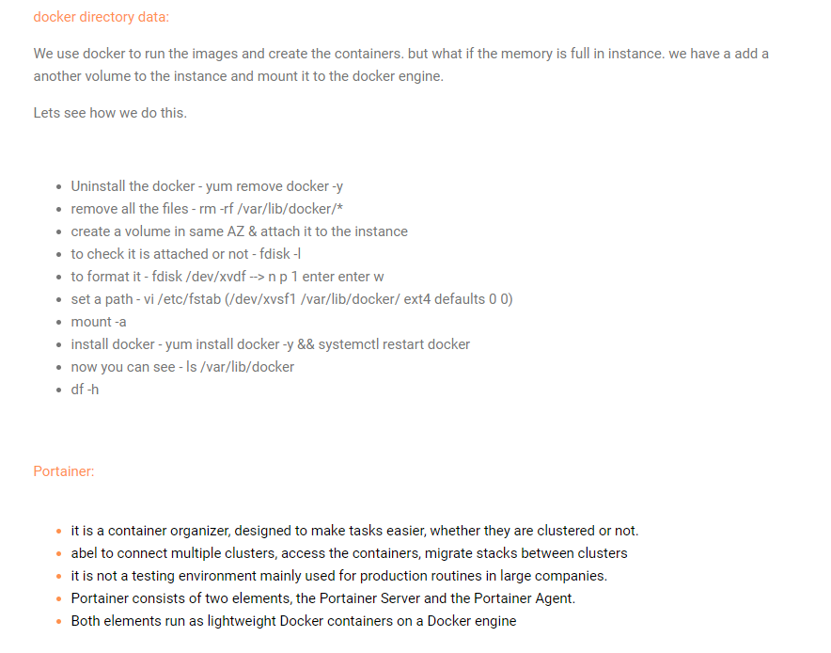

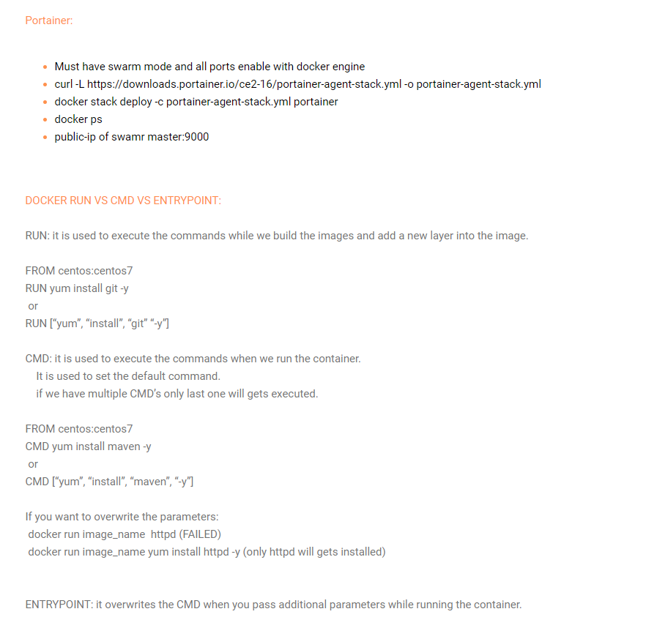

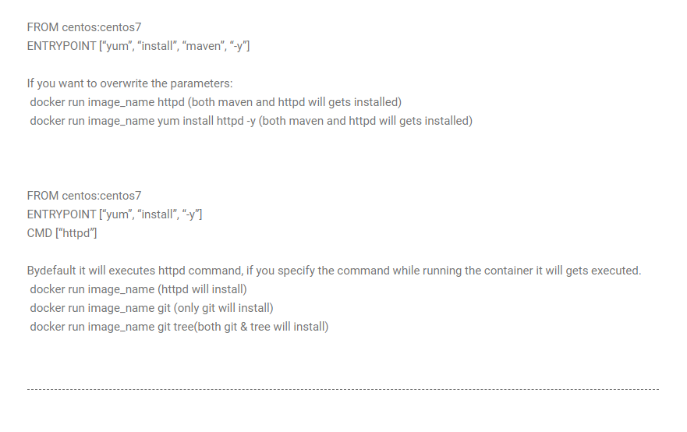

## HTTP/1.1: Status Code Definitions – Glossary

| **Code** | **Constant** | **Reason Phrase** |
| --- | --- | --- |
| 100 | CONTINUE | Continue |
| 101 | SWITCHING_PROTOCOLS | Switching Protocols |
| 102 | PROCESSING | Processing |
| 200 | OK | OK |
| 201 | CREATED | Created |
| 202 | ACCEPTED | Accepted |
| 203 | NON_AUTHORITATIVE_INFORMATION | Non Authoritative Information |
| 204 | NO_CONTENT | No Content |
| 205 | RESET_CONTENT | Reset Content |
| 206 | PARTIAL_CONTENT | Partial Content |
| 207 | MULTI_STATUS | Multi-Status |
| 300 | MULTIPLE_CHOICES | Multiple Choices |
| 301 | MOVED_PERMANENTLY | Moved Permanently |
| 302 | MOVED_TEMPORARILY | Moved Temporarily |
| 303 | SEE_OTHER | See Other |
| 304 | NOT_MODIFIED | Not Modified |
| 305 | USE_PROXY | Use Proxy |
| 307 | TEMPORARY_REDIRECT | Temporary Redirect |
| 308 | PERMANENT_REDIRECT | Permanent Redirect |
| 400 | BAD_REQUEST | Bad Request |
| 401 | UNAUTHORIZED | Unauthorized |
| 402 | PAYMENT_REQUIRED | Payment Required |
| 403 | FORBIDDEN | Forbidden |
| 404 | NOT_FOUND | Not Found |
| 405 | METHOD_NOT_ALLOWED | Method Not Allowed |
| 406 | NOT_ACCEPTABLE | Not Acceptable |
| 407 | PROXY_AUTHENTICATION_REQUIRED | Proxy Authentication Required |
| 408 | REQUEST_TIMEOUT | Request Timeout |
| 409 | CONFLICT | Conflict |
| 410 | GONE | Gone |
| 411 | LENGTH_REQUIRED | Length Required |
| 412 | PRECONDITION_FAILED | Precondition Failed |
| 413 | REQUEST_TOO_LONG | Request Entity Too Large |
| 414 | REQUEST_URI_TOO_LONG | Request-URI Too Long |
| 415 | UNSUPPORTED_MEDIA_TYPE | Unsupported Media Type |
| 416 | REQUESTED_RANGE_NOT_SATISFIABLE | Requested Range Not Satisfiable |
| 417 | EXPECTATION_FAILED | Expectation Failed |
| 418 | IM_A_TEAPOT | I’m a teapot |
| 419 | INSUFFICIENT_SPACE_ON_RESOURCE | Insufficient Space on Resource |
| 420 | METHOD_FAILURE | Method Failure |
| 421 | MISDIRECTED_REQUEST | Misdirected Request |
| 422 | UNPROCESSABLE_ENTITY | Unprocessable Entity |
| 423 | LOCKED | Locked |
| 424 | FAILED_DEPENDENCY | Failed Dependency |
| 428 | PRECONDITION_REQUIRED | Precondition Required |
| 429 | TOO_MANY_REQUESTS | Too Many Requests |
| 431 | REQUEST_HEADER_FIELDS_TOO_LARGE | Request Header Fields Too Large |
| 451 | UNAVAILABLE_FOR_LEGAL_REASONS | Unavailable For Legal Reasons |
| 500 | INTERNAL_SERVER_ERROR | Internal Server Error |
| 501 | NOT_IMPLEMENTED | Not Implemented |
| 502 | BAD_GATEWAY | Bad Gateway |
| 503 | SERVICE_UNAVAILABLE | Service Unavailable |
| 504 | GATEWAY_TIMEOUT | Gateway Timeout |
| 505 | HTTP_VERSION_NOT_SUPPORTED | HTTP Version Not Supported |
| 507 | INSUFFICIENT_STORAGE | Insufficient Storage |
| 511 | NETWORK_AUTHENTICATION_REQUIRED | Network Authentication Required |